**TABLE OF CONTENT**

**CHAPTER NO TITLE PAGE NO**

**ABSTRACT**

**LIST OF FIGURES**

**LIST OF TABLES**

**LIST OF ABBRIVATION**

1. **INTRODUCTION**

1.1 MINING AND STORAGE 01

1.2 RAW MATERIAL 02

1.3 FORMING THE BRICK 03

1.4 DRYING 04

1.5 FIRING AND COOLING 04

1.5.1 FIRING 05

1.5.2 COOLING 06

1.6 STORING PRODUCTS 06

**2.**  **LITERATURE REVIEW** 07

**3.** **EXISTING SYSTEM**

**AND PROPOSED SYSTEM**

3.1 METHODS OF KILNS 10

3.1.1 DOWN DRAUGHT KILN 10

3.1.2 COAL-FIRED 11

3.1.3 FIXED CHIMNEY 12

3.1.4 CLAMP KILN 13

3.1.5 TUNNEL 14

3.16 ZIG ZAG 15

3.1.7 VERTICAL SHAFT BRICK KILN 16

3.18 BULL’S TRENCH KILNS 19

3.2 EXISTING SYSTEM 20

3.3 CAUSES 21

3.4 DISADVANTAGES 21

3.5 PROPOSED SYSTEM 22

3.6 ADVANTAGES 23

4 **DESIGN AND WORKING**

4.1 BLOCK DIAGRAM 24

4.2 WORKING 26

4.3 FLOW CHART 27

4.4 POLLUTION CAUSED 28

4.5 ADVANTAGES 28

**5**  **HARDWARE DEVELOPMENT**

**AND TESTING**

5.1 COMPONENTS 29

5.1.1 ARDUINO 29

5.1.2 POWER 31

5 .1.3 POWER PINS 32

5.1.4 MEMORY 32

5.1.5 INPUT AND OUTPUT 32

5.1.6 COMMUNICATION 33

5.1.7 PROGRAMMING 34

5.1.8 AUTOMATIC RESET 34

5.1.9 OVERCURRENT PROTECTION 35

5.2 LIQUIDE CRYSTAL DISPLAY 35

5.3 RELAY 37

5.4 PRINCIPLE 39

5.5 LOAD CELL 40

5.6 LOAD CELL TYPE 41

5.7 POWER SUPPLY 50

5.8 TRANSFORMER 50

5.9 CAPACITOR FILTER 51

**6.**   **SOFTWARE**

6.1 CIRCUIT DIAGRAM 53

6.2 SOFTWARE CODE 54

6.3 TEST RESULT 56

**7**.  **CONCLUSION AND FUTURE SCOPES**  57

# CHAPTER 1

# INTRODUCTION

One of the earliest types of building materials is brick, which dates to about 7000 BC. They were found in southern Turkey, close to the historic settlement of Jericho, where a tiny community formerly stood. Clay was used to making the first bricks, and it was baked in the sun until it became hard. Mud bricks are the name for these bricks. The term "brick" is now frequently used to refer to any construction block that has undergone chemical curing. Technically speaking, a brick is a dried-out clay block used to build masonry structures like walls, pavements, and other components.

## 1.1 MINING AND STORAGE OF RAW MATERIAL

Brick is a kind of building material that can be used to create masonry elements like walls, pavements, and other aspects. Originally referring to a block of burned clay, the term "brick" is now frequently used colloquially to refer to a variety of construction blocks that have undergone chemical curing. One of the earliest building materials is thick, which dates to about 7000 BC. They were found in southern Turkey at the location of an old settlement that once encircled Jericho. The original bricks were created in warm climates from mud and were sun-dried to become firm.

Surface clays and shales are mined from open pits and used to make brick and other structural clay products. Depending on the plant, the raw materials' moisture level ranges from about 3% to roughly 15%. While some facilities import raw materials via truck or rail, others have their mining activities. A primary crusher reduces the size of the raw material before moving it to a grinding chamber. There, a blend of screens and grinding mills create a fine material that to manufacture or other things.

The most common way to make bricks is by using the stiff mud extrusion method. This method involves grinding the raw material, mixing it with water in a pug mill, and removing the air in a vacuum chamber. Some plants add barium carbonate to the mixture to prevent sulfates from forming on the brick surface. The mixture has a moisture content of 14 to 18 percent when it enters the vacuum chamber. It is then pushed through dies or augers to shape the bricks. The stiff mud extrusion method is different from the soft mud and dry press methods, which are less widely used in the United States. To reduce the friction that occurs during the extrusion process, oil or another lubricant is applied to the continuous "column" that is formed by forcing the material through a die.

The clay is treated with different surface agents, such as manganese dioxide, iron oxide, and iron chromite, to give it color or texture if desired. Then, a wire-cutting machine slices the clay column into individual bricks, which are either mechanically or manually placed on kiln cars. This process is used for all structural tiles and most bricks. Some facilities also shape the unfired bricks to create rounded edges that resemble old worn bricks. The soft mud process is an alternative method for clay that is too wet for stiff mud extrusion. It involves mixing the clay with water to a moisture content of 15 to 28 percent in a pug mill, forming the bricks in molds, and drying them before stacking them on kiln cars. The dry press process is another method that uses clay with a small amount of water and forms it in steel molds by applying pressure of 500 to 1,500 pounds per square inch (3.43 to 10.28 megapascals).

**1.2 PREPARING RAW MATERIAL**

The process of preparing raw materials uses a lot of electricity, often 25 to 35 kWh for every ton of raw material. There are instances when it is only 11 kWh per tonne Before being used to create clinker, the raw materials must be refined and ground. The kind of grinding will determine the kind of preprocessing that will happen next. Either dry processing or wet processing is used to transform the raw materials into a "raw meal". In dry processing, ball mills or roller mills are used to grind the raw materials into a powder. Steel balls are used in a ball (or tube) mill to crush the raw material particles inside a spinning tube.

Raw materials with more than 20% water content should be processed wet. In the wet process, the raw materials are ground in a ball mill along with water to create a slurry that contains 24–48% water. Different levels of wet processing, such as semi-wet (17–22% moisture content), can aid in lowering kiln fuel usage.

After preparing the raw materials, several forming (shaping) procedures are performed, depending on the final product's intended shape and appearance. Extrusion is a typical technique for structural ceramics, occasionally combined with plastic pressing. Plastic pressing is more usually applied to roof tiles and vases and less frequently to bricks and specialty items. Ceramic tiles are typically created using uniaxial hydraulic presses and semi-dry pressing (5–8% moisture content on a dry basis). However, some ceramic tiles, like rustic floor tiles, are extruded to give them a particular aesthetic look. Typically, either isostatic pressing or uniaxial pressing is used to create refractory bricks.

One of the most common methods for making tableware and decorative ceramics is air slip casting in plaster molds. This method involves pouring a thick liquid made of ceramic particles into a plaster mold. The plaster absorbs some of the water from the liquid, leaving behind a solid ceramic product that matches the shape of the mold. Another method that is used for making dinnerware is a plastic mounding, which can be easily automated to make many pieces quickly. This method involves shaping soft clay on a rotating wheel or a machine. Some ceramic items, such as plates and platters, are made by pressing, which is a fast and efficient way of making thin and flat products Isostatic pressing is a technique for forming ceramic tableware that uses a fluid to apply equal pressure on all sides of a rubber mold containing the spray-dried powder. This method allows for the production of flat or deep items with various shapes and designs, such as plates, bowls, platters, casseroles, and pans. Isostatic pressing is necessary for this situation because porcelain tableware has less symmetry than ceramic tiles and requires more precise and uniform shaping. In contrast, the classic air slip casting method with plaster molds is still used to form vitreous china sanitary ware, which is mostly symmetrical and hollow items. Pressure slip casting with resin molds is another alternative for producing asymmetrical or complex items with high quality and efficiency. The advantage of this forming technique is that it can produce the desired thickness more quickly than air slip casting, and the modules do not need to be dried after each cycle.

**1.3 FORMING THE BRICK**

The steps involved in molding (shaping) raw materials differ from those involved in preparing them. The final product's shape and appearance are determined by the forming process. For instance, structural ceramics are manufactured using extrusion and plastic pressing, whereas ceramic tiles are manufactured using semi-dry pressing and hydraulic presses. To give them a more rustic appearance, certain ceramic tiles are also extruded. Uniaxial or isostatic pressing, sometimes under extremely high pressures, is how refractory bricks are made. The most popular technique for creating ceramic dinnerware and ornamental items is slip casting in plaster molds. It entails suctioning some water out of a plaster mold after filling it with a dense suspension of particles. The finished result replicates the interior of the mold. Another technique for producing tableware, particularly for automated production, is plastic molding. Isostatic pressing is required for thin items, including plates and platters. This technique applies pressure uniformly to the spray-dried powder using a rubber mold and a fluid.

Different forming techniques can be employed by manufacturers to create vitreous China sanitary ware. One of them continues to be used today is the conventional air slip casting technique using plaster molds. However, pressure slip casting using resin molds is currently the most often used forming technique. This approach has the benefit of achieving the correct thickness more quickly and does not call for the mold to be cured.

## 1.4 DRYING

The moisture content of wet brick varies from 7 to 30 percent, depending on how it is formed by molding or cutting machines. Before firing, the brick is dried in chambers with temperatures between 100oF and 400o F (38o C and 204o C) for 24 to 48 hours, depending on the clay type. This removes most of the water from the brick. The heat for the dryer chambers can be generated from the kiln exhaust to increase thermal efficiency. The heat and humidity levels in the dryer chambers must be carefully regulated to avoid brick cracking. Some moisture remains in the brick after the drying process. To prevent cracking during the firing process, raw bricks must be dried properly. The drying of raw bricks is a natural process that takes time and care. The bricks are arranged in stacks of eight to ten stairs each, leaving enough space between them for air to flow. This allows the bricks to dry naturally, which can take up to 10 days depending on the weather conditions. The drying yards are located at higher altitudes to avoid flooding during rainy seasons. In some cases, artificial drying methods such as special dryers or hot gases are applied to speed up the process.

## 1.5 FIRING AND COOLING

The firing and cooling is the last step of brick manufacturing, after firing and colling the brick was used to for building(walls) construction. The details of firing and colling is giaren bellow:

### 1.5.1 Firing

The duration of brick firing varies from 10 to 40 hours, depending on the kiln type and other factors. Manufacturers use different kinds of kilns, such as tunnel kilns and periodic kilns. The fuels for these kilns can be natural gas, coal, sawdust, methane gas from landfills, or combinations of these. In a tunnel kiln (see Photo 4), bricks are placed on kiln cars that move through various temperature zones. Each zone has a precise heat control, and the kiln operates continuously Periodic kilns are a type of kiln that are operated in cycles of loading, firing, cooling, and unloading. They are used for firing bricks and other ceramic products. The bricks are arranged in the kiln with gaps to allow the hot gases to circulate and heat them evenly. The bricks are loaded directly from the dryer and the temperature is gradually increased until the desired level is reached.

## A) The firing process consists of five main stages

* Final drying: The remaining water in the bricks evaporates.
* Dehydration: The chemically bound water in the clay minerals is removed.
* Oxidation: The organic matter and iron compounds in the clay are oxidized, changing the color and strength of the bricks.
* Vitrification: The clay particles fuse forming a glassy matrix that makes the bricks hard and durable.
* Cooling or flashing: The temperature is lowered slowly to avoid thermal shock and cracking. The bricks may also be exposed to different atmospheres to create color effects.

The kiln's temperature affects different stages of clay processing. In the drying stage, the clay loses its final moisture at up to 400oF (204oC). The dehydration stage removes chemically bound water from 300oF to 1800oF (149oC to 982oC). The oxidation stage changes the clay's color and texture from 1000oF to 1800oF (538oC to 982oC). The vitrification stage transforms the clay into a solid and durable material with low absorption from 1600oF to 2400oF (871oC to 1316oC). Unlike metal, clay does not have a sharp melting point, but softens and vitrifies gradually as the temperature rises.

## B) The process of melting involves three phases

* Initial fusion, where the clay particles soften enough to form a cohesive mass when cooled.
* Vitrification, in which the mass becomes solid, dense, and impermeable due to significant fluxing.
* Viscous fusion, causes the clay mass to deform and collapse as it melts.

To avoid viscous fusion and achieve partial vitrification and initial fusion, it is crucial to control the kiln's temperature during the firing process. The raw materials, the dimensions, and the coring of the brick being produced, as well as the speed of temperature change, all need to be carefully adjusted. Kilns usually have temperature sensors to monitor different firing temperatures.

### 1.5.2 Cooling

The next stage of brick-making is cooling, which begins after the temperature has reached and maintained a set level for a specific duration. Cooling times vary depending on the type of kiln, with tunnel kilns taking up to 10 hours and periodic kilns taking between 5 and 24 hours. Cooling is an important step because it influences the color of the bricks through the cooling rate.

## 1.6 DE-HACKING AND STORING PRODUCTS

After the brick has cooled, the process of de-hacking involves emptying a kiln or kiln car, which is frequently done by robots (see Photo 5). Robots frequently carry out De-hacking, which is the process of removing bricks from a kiln or kiln car after they have cooled (see Photo 5). Bricks are graded, packaged, and sorted. After that, they are either put in a storage area or loaded onto trucks or rail wagons to be delivered. For ease of handling on the job site, the bulk of bricks is now packaged in self-contained, strapped cubes that can be divided into separate strapped bundles. The containers and cubes are designed with apertures for forklift handling. Global energy-related CO2 emissions increased by 0.9%, or 321 tons, in 2022. The containers and cubes are designed with apertures for forklift handling. According to the research, global energy- related CO2 emissions increased in 2022 by 0.9%, or 321 million tons, hitting a record high of more than 36.8 billion tons. Brick kilns are still used in the traditional manner, which results in roughly 15% (5.52 billion tons) of carbon emissions.

# CHAPTER 2

## LITERATURE SURVEY

**GARAY AQUINO, DENNIS RAUL, CARLOS QUISPE ANCCASI: “*PROPOSAL FOR IMPLEMENTATION OF INDUCTION STOVES FOR ELECTRIFICATION OF THE PERUVIAN 00000ENERGY MATRIX*”.**

This document recommends the use of induction stoves in the electrification of Peru's electrical grid. The major goal of this proposal is to show that, in comparison to gas stoves, which are now the most popular, induction stoves are a practical and superior option for cooking in Peru. The idea is built on the five pillars of affordability, competitiveness, efficiency, environmental sustainability, and safety in the efficient energy transition. A multi-criteria analysis that took into account technological, economic, social, and environmental considerations was used to analyze these aspects. The proposal also took into account Peru's present and future power demand and supply, as well as any potential effects of induction stoves on the stability and dependability of the grid. The concept of the efficient energy transition is based on the five pillars of affordability, competitiveness, efficiency, environmental sustainability, and safety. These characteristics were examined using a multi-criteria analysis that considered technological, economic, social, and environmental factors. The proposal also considered the availability and demand of electricity in Peru both now and in the future, as well as any potential consequences of induction stoves on the grid's dependability and stability [1].

* Offering low-income households financial assistance or incentives to buy induction stoves and kitchenware that works with them.
* Developing education and training programmers on the advantages and appropriate use of induction stoves for consumers and retailers.
* Creating quality guidelines and standards for induction cookware and stoves to guarantee their effectiveness and safety.
* Improving the infrastructure and distribution system for power to meet the rising demand for induction stoves.
* Carrying out more research and development to enhance the efficiency and robustness of induction stoves and to investigate alternative uses for induction technology in Peru.

**GURMU M. DEBELE, XIAO QIAN:** “***AUTOMATIC ROOM TEMPERATURE CONTROL SYSTEM USING ARDUINO UNO R3 AND DHT11 SENSOR*”.**

A sensor called the DHT11 can gauge the air's temperature and humidity. It can be utilized to keep track of the room's temperature and alert the user when it rises above a set limit. Avoiding overheating or freezing, this contribute to the creation of a cosy cozysecure atmosphere for people or equipment. The DHT11 sensor is simple to use and uses little power [2].

**A. RASHEEDHA, K. SRINATHI, T. SIVALAVANYA, R.R. MONESHA: “*ARDUINO-BASED AUTOMATED DOSAGE PRESCRIPTION USING LOAD CELL*”.**

The objective of this project is to develop and test a system that can intelligently suggest a patient's medicine dosage based on their height and weight. The system is made up of an HX711 ADC module, a microcontroller, a display unit, a dispenser unit, and a weight sensor (also known as a load cell). The HX711 ADC module receives an analog signal from the weight sensor, also known as the load cell, indicating the patient's weight[3]. Between the weight sensor and the microcontroller, the HX711 ADC module acts as a bridge. It enhances and converts an analog signal to a digital signal. The microcontroller receives the digital signal from the HX711 ADC module and uses the following formula to determine the patient's body mass index (BMI).

**M. MUTHUMARI, NITESH KUMAR SAH, RISHU RAJ, JYOTIKINKAR SAHARIA: “*ARDUINO-BASED AUTO DOOR UNLOCKS CONTROL SYSTEM BY ANDROID MOBILE THROUGH BLUETOOTH AND WI-FI*”.**

The auto door unlock system (ADUS), which enables the user to open the door with their smartphone, is a recent invention in smart home technology. For homeowners who wish to control entry to their house from anywhere, this system offers convenience, security, and energy economy. The ADUS connects the smartphone and door lock via Bluetooth technology. Once connected, the user can use their smartphone as a key to unlock the door whenever they are nearby. Additionally, the user can grant others, such family members, friends, or service providers, temporary or permanent access to their handsets[4].

Additionally, the ADUS has a Wi-Fi camera capability that enables users to use their smartphones to see who is at the door. The user's phone receives an image taken by the camera of the person or people at the door. After that, the user has the option of either opening the door or not, or even speaking with the visitor via a two-way audio system.

**a) The ADUS offers several benefits for homeowners, such as:**

* Convenience: The user won't have to worry about carrying around physical keys or losing them. Additionally, they can use their smartphone to unlock the door from anywhere in the world.
* Security: The user has the ability to keep an eye on who is at the door and thwart unauthorised entry. Additionally, they are able to get notifications if someone tries to force the door open or tamper with the lock.
* electricity efficiency: By turning off lights and appliances when they leave the house and turning them back on when they get home, the user can conserve electricity. Additionally, they can change the thermostat's settings to suit their schedule and tastes.
* One automation method that can improve home life quality, safety, and intelligence is the ADUS.

**ALOKE RAJ SARKAR, DEBANGSHU DEY, SUGATA MUNSHI:**

**“*LINEARIZATION OF NTC THERMISTOR CHARACTERISTIC USING OP- AMP BASED INVERTING AMPLIFIER*”.**

We suggest a fresh method for linearizing the output of an NTC thermistor using a straightforward operational amplifier-based inverting amplifier circuit. The circuit uses the amplifier's negative feedback to balance out the thermistor's nonlinear behavior [5]. The circuit's ability to attain a high linearity of roughly 1% over a wide temperature range of 30 °C to 120 °C is demonstrated through experimentation. Moreover, over a narrower temperature range, the linearity can be increased to 0.5%. By altering the feedback resistor's value, the circuit also enables variable gain control. The proposed method has advantages in that it is inexpensive, simple to use, highly reliable, and drift- free.

# CHAPTER 3

## EXISTING SYSTEM AND PROPOSED SYSTEM

### 3.1 METHODS OF KILNS

Brick kilns are historic buildings that employ fire to harden clay products like tiles and ceramics. They can be made in simple or intricate shapes, but they all require a wood fire and a level, open space outside. Knowing the size of the items you'll be burning and the quantity of bricks required to construct the walls and base will help you create your own brick kiln. For the top of the kiln, you also need a piece of iron or ceramic fiber. Here are some actions to take:

* Multiply the width and length of the largest object you want to fire by 1.5 to determine the kiln's internal dimensions. The inner height of the kiln is increased by the height of a firebrick. The inner length and width of the kiln should be double the dimensions of a firebrick.
* The kiln's base is constructed by placing bricks level against one another on a flat surface. The base should be the same size as the kiln's outside length and width.
* To build the kiln's walls, pile bricks on three of the base's sides. Keep a side open so you may insert your objects into the kiln.
* For the kiln's roof, use a corrugated iron sheet or a sheet made of ceramic fiber on top of the brick walls.
* In the kiln, start a wood fire, and let it burn until the items become hard.

#### 3.1.1 DOWN DRAUGHT KILN

In down draught kilns, a kind of intermittent kiln, bricks are burnt in batches. Hot fuel gases are directed to the top of the kiln and then dragged downward down the chimney to heat the green bricks. Early in the 19th century, this kiln was developed as an improvement on the widely used clamp kilns of the period. One of the benefits of this kiln is that it may prevent the fuel and its byproducts from contaminating the bricks.

In down draught kilns, a kind of intermittent kiln, bricks are burnt in batches.

Bricks are fired in batches in a down draught kiln (DDK), a form of intermittent kiln.

It has a refractory lining and a permanent framework composed of burnt bricks. The

kiln has a chimney (1.2) and a fire chamber (1.1), which are connected by an underground flue duct (1.3). There are fireboxes (1.4) on either side of the chamber where the fuel is burned. From the fig. 3.1 shown.

The DDK has one chimney that is shared by two or four chambers, each of which is operated alternately. Each chamber has a batch capacity of 20,000–40,000 bricks. Without being in contact with the flames, the bricks are placed in the chamber. Fired by the chimney draught, the hot gases produced by fuel combustion rise to the kiln's roof (Figure 3.1.1) and then descend through the green bricks.

A 30-hour firing procedure is followed by a two- to three-day cooling period. It takes 7 to 10 days to complete the entire cycle from loading and firing to cooling and unloading. The DDK creates high-quality bricks that distribute heat evenly. The heat from the bricks and the kiln structure is lost to the atmosphere during cooling, hence it has a low heat recovery efficiency.

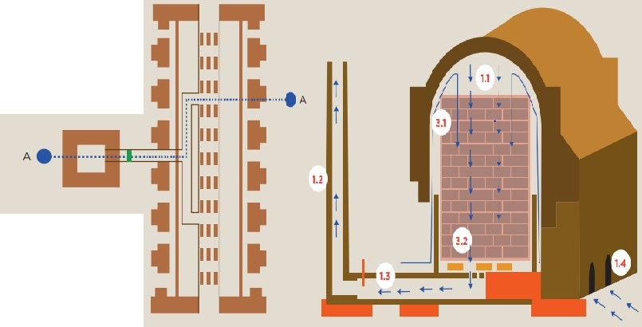

**Fig. 3.1 Down Draught kiln**

##### 3.1.2 COAL-FIRED

More than a century has passed since pulverized coal began to be burned. However, it is still unclear how fly ash and coal dust are formed and how they burn. Our study team has gathered samples of partially combusted coal dust from a pulverized coal burner flame at the Drava Lime Company in Maysville, Kentucky. We used an energy dispersive spectrometer (EDS) and a scanning electron microscope (SEM) to examine the materials. We may put forth a theory on how combustion proceeds through a coal dust particle by looking at the microscopic structure of the particles and the micrographs of lime dust linked to fly ash particles. The coal particle encounters turbulent gas as it leaves the burner pipe. The lighter compounds in the particle will ignite due to the kiln gas heat and radiation heat from the kiln interior. The diffusion of oxygen into the combustion zone will be accelerated by turbulence. It is mostly unknown what a kiln's gas temperature profile is. Only the conditions at the firing hood's input and the product feed end of the kiln's outflow can be measured. Frequently, the refractory temperature in the firing zone is 1400°C.

You can use coal as an alternative fuel to reduce the deforestation brought on by the usage of firewood for producing bricks. Bricks made from coal are of high quality and may be made in huge quantities. A field kiln powered by coal must be built and fired differently than one powered by firewood. Here are the procedures for building and running a coal-fired, 20,000-brick field kiln. The kiln will be roughly 4 metres in length, 4 metres in breadth, and 3.5 metres in height.

#### 3.1.3 FIXED CHIMNEY BULL'S TRENCH KILN

Motionless chimney In South Asia, the Bull's Trench Kiln (FCBTK) is a common brick-firing method. Bricks are stacked inside of an annular area created by an outer and an interior wall. A fire burns through the bricks in a circular or oval circuit (central perimeter 180–220 m), firing 20,000–50,000 bricks in a day. The fire moves 6 to 10 meters each day and heats, fuses, and cools the bricks continuously in various parts of the kiln. This method is based on W. Bull's trench kiln, a British engineer invention from 1876.

Metal chimneys that were moveable and moved with the flames were part of the original concept. Bull's Trench Kilns with fixed chimneys, which are more effective and less harmful, later took their place. In the 1990s, India outlawed the use of portable chimney kilns; Bangladesh and Nepal also enacted rules along the same lines.

A brick kiln with a permanent chimney and a circular or oval trench for burning bricks is known as an FCBTK. A natural draught caused by the chimney's 20-38 m height allows air to pass through the kiln. The fire, preheating, and cooling zones make up the kiln. Firemen feed the fuel such as coal, wood, or agricultural waste through apertures at the top of the kiln. As shown in below Fig. 3.2.

The bricks are arranged vertically in columns with openings for air to enter through, and the fire travels in a closed circuit through them. Ash and brick dust are used to cover the bricks to stop heat loss and air leakage. Green bricks are loaded at the front end of the preheating zone while burnt bricks are discharged from the back end of the cooling zone. The fire burns 20,000–50,000 bricks every day and moves 6–10 meters per day. In Pakistan, Bangladesh, Nepal, and India, brick manufacture is facilitated by the FCBTK, a low-cost and widely used technology.

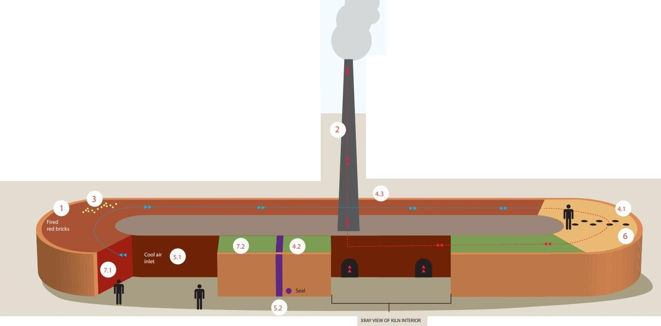

**Fig. 3.2 Fixed Chimney Bull's Trench Kiln**

##### 3.1.4 CLAMP KILN

Bricks are traditionally cooked using a brick clamp, which involves stacking unbaked bricks with fuel underneath or between them before lighting the fuel. The Fig.

3.3 shows the method of clamp kiln. An example of a kiln is the clamp. The clamp turns into a scope kiln if dirt or mud is packed around it to insulate it. The following are some benefits and drawbacks of employing a brick clamp:

* The clamp is a temporary building that can be erected close to the work site, saving money and time on transportation.
* Depending on the clamp's size and construction, it can burn a sizable number of bricks (20,000 to 100,000) in one to two months.
* The clamp is appropriate for small-scale projects because it doesn't need specialized supervision or expensive upfront costs.
* The clamp may run on inexpensive fuels that are widely available in rural

regions, including cow manure, grass, etc.

* If the burning is done properly, the clamp can yield a high percentage of high- quality bricks (more than 60%).
* Nevertheless, there are some disadvantages to employing a brick clamp as well:
* Because bricks take a long time to burn and cool (two to six months), the clamp cannot keep up with the demand for them.
* The clamp lacks fire control, which could cause bricks to burn too quickly or too slowly, lowering the quality and strength of the bricks.
* The clamp loses a lot of heat since it is poorly insulated and lacks a vent or chimney to channel the hot gases.
* As the fuel burns, the clamp may emit ash and smoke that pollute the environment.

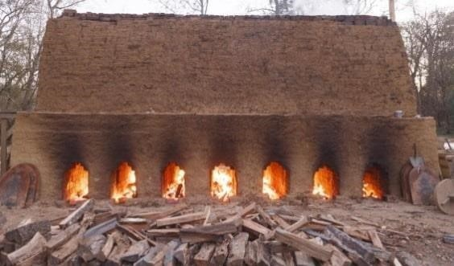

**Fig. 3.3 Clamp Kiln**

##### 3.1.5 TUNNEL

An example of a continuous kiln is a tunnel kiln, which transports clay products on vehicles along a horizontal tunnel for fire. In the center of the tunnel, where the temperature is the highest, the products are burnt. Since it can burn a variety of clay products with better control and quality, tunnel kilns are recognized as the most cutting- edge technology for creating bricks. The method was developed in Germany in the middle of the 19th century, but it wasn't really used until the 20th century for brick firing. Tunnel kiln technology swept throughout Europe following World War II, replacing thousands of tiny, dispersed brick-making units with a few hundred massive, automated ones. In Asia, hundreds of tunnel kilns are currently in use after China and Vietnam adopted the technology in the 1970s. However, there are only a few (5) tunnel kiln plants in India. The Fig. 3.4 shows the image of tunnel brick kilns.

An example of a continuous moving ware kiln is a tunnel kiln, in which the bricks or clay products are loaded onto cars and driven down a lengthy horizontal tunnel. The tunnel's center, which might be 60 to 150 meters long, is where the bricks are burnt. By combining clay and fuel powder, the green bricks are created, which are then dried on cars in tunnel or chamber dryers. The hot flue gases leaving the kiln provide the heat needed for drying. At regular intervals, the carriages containing the dry green bricks are pushed into the kiln. A firing cycle may last between 30 and 72 hours. There are three areas in the tunnel kiln: the brick burning zone, where the fuel is fed and burned; the brick preheating zone, where the flue gases from the firing zone heat the green bricks; and the brick cooling zone, where the cooked bricks are cooled by the cold air entering the kiln. Coal that has been ground into granules or powder is fed into the firing zone through openings in the kiln roof. Usually 8 cars long, the firing zone has a temperature range of 900 to 1050 degrees Celsius. In the kiln, the air and the bricks flow in the opposing directions. The cold air enters from the automobile exit end and warms up as it cools the bricks that have been burnt. A portion of the heat from the hot flue gases is transferred to the green bricks entering into the kiln at the car entrance end. At certain points, some of the hot air or gases are removed from the kiln and used for drying.

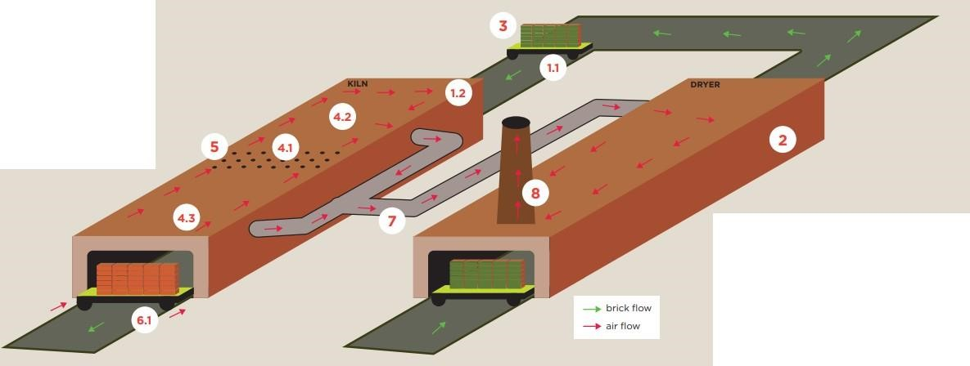

**Fig. 3.4 Tunnel**

##### 3.1.6 Zigzag

A continuous-operational form of kiln that makes use of an updraft and a moving-ware system is known as a vertical shaft brick kiln (VSBK). The air and the bricks move in opposition to one another while the fire remains stationary, resulting in a countercurrent heat exchange. The ancient up-draught kilns in rural China were where the VSBK technology was born in the late 1950s, but it gained popularity after the economic reforms. There were thousands of VSBKs running in China around the middle of the 1990s. The Fig 3.5 shows zigzag method kilns.

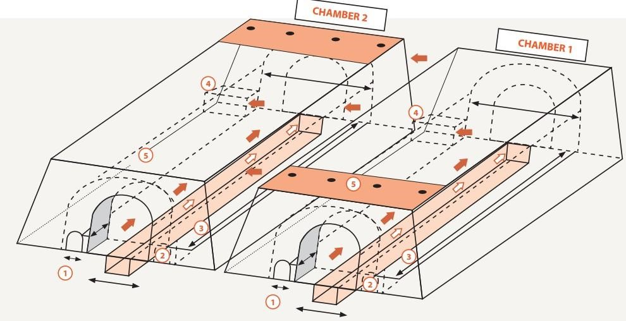

**Fig. 3.5 zig-zag**

##### 3.1.7 Vertical shaft brick kiln

Vertical shaft brick kiln (VSBK) is a continuous, updraft, moving ware kiln in which the fire remains stationary while there is counter-current heat exchange between air (moving upward) and bricks (moving downward).

Vertical shaft brick kiln (VSBK) is a continuous, updraft, moving ware kiln in which the fire remains stationary while there is counter-current heat exchange between air (moving upward) and bricks (moving downward). The VSBK technology evolved from the traditional up-draught kilns in rural China during the late 1950s; however, the widespread dissemination of the technology took place after the economic reforms. At its peak during the mid-1990s. Since 1990, the technology has also been distributed to additional developing nations including Vietnam, India, and Nepal through various ventures. However, while VSBK technology has been widely adopted in Vietnam, it has been adopted more slowly in India and Nepal. The method has been enhanced and altered by Vietnamese brick builders to make it more appropriate for industrial application. The Fig. 3.6 shows VSBK.

Since 1990, the technology has also been distributed to additional developing nations including Vietnam, India, and Nepal through various ventures. Nevertheless, the use of VSBK technology vertical shaft brick kiln using the VSBK technology creates high-quality bricks with no harm to the environment. It was created in China, where it was said that there were thousands of VSBKs in use. In various technology transfer efforts since 1990, the technology has been distributed to a number of developing nations, including Vietnam, India, and Nepal. VSBK technology has spread rather slowly in India and Nepal, but it has had excellent results in Vietnam. Vietnamese brick builders have improved the technology and added additional features, changing it from a rural to an industrial technology.

* An energy-efficient and environmentally friendly kiln, the vertical shaft brick kiln (VSBK) creates high-quality bricks by heating the material in a vertical shaft with a rectangle or square cross-section. The cross-section size can range from 1.0 x 1.5 meters to 1.75 x 3.75 meters, and the shaft height is between 6 and 10 meters. The kiln often contains two or more shafts, an outside brick wall, and insulation made of glass wool, clay, fly ash, or rice husk.
* Two chimneys at the corners connected to the shafts provide an updraft of hot air and gases. Green bricks and fuel are fed into the shaft at the top of the shaft using conveyors, lifts, or manual labor. The top of the shaft is covered by a roof and has a working platform. Depending on quality and availability, the fuel may be biomass-based green solid briquettes, briquettes, or coal. As internal or external fuel, the fuel is either blended with the green bricks or positioned between them.
* The center area of the shaft, where the temperature reaches about 1100 degrees Celsius, is where the fuel is burned, and it is where the green bricks are fired as they progress down the shaft. The ambient air that enters from the shaft's bottom cools the burnt bricks before they are discharged. The kiln is divided into three sections: the preheating zone, where flue gases warm the green bricks; the firing section, where the fuel burns and the bricks reach their peak temperature; and

the cooling section, where the burned bricks lose heat and are prepared for unloading.

* The keywords explain how a vertical shaft brick kiln operates. A possible text based on the keywords is as follows:
* A form of kiln that uses the counter current heat exchange principle is the vertical shaft brick kiln. Bricks are stacked in batches and dropped downward by gravity in a vertical shaft. The preheating zone, the combustion zone, and the brick cooling zone are the three primary zones in the shaft.
* The green bricks are loaded into the preheating zone at the top of the shaft, where they are exposed to the combustion zone's hot flue gases. By doing so, the bricks are warmed up and the combustion zone uses less fuel. Through chimneys at the top of the shaft, the flue gases leave the kiln.
* Air is brought into the combustion zone from the shaft's bottom and heated by the red bricks in the brick cooling zone. The fuel (coal, wood, or biomass), which is burned in the combustion zone, produces heat that is used to fire the bricks. The combustion zone lies in the center of the shaft and is continuously heated to a temperature between 900 and 1000 °C.
* The burnt bricks are removed from the shaft's bottom and positioned on a trolley in the brick cooling area. The red bricks in the brick cooling zone serve as a heat recovery mechanism by transferring their heat to the entering air. Every two to three hours, a batch of bricks containing 200 to 300 are unloaded. At any given time, the kiln can have 8 to 12 batches running.

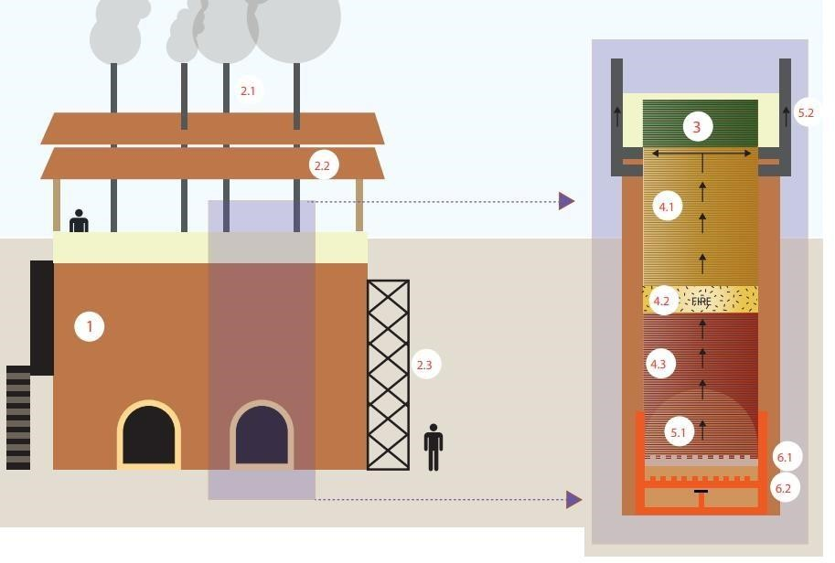

**Fig. 3.6 Vertical Shaft Brick Kiln**

#### 3.1.8 Bull's trench kilns

Fired ceramic bricks have a more than three-thousand-year history and are still widely used to construct homes around the world. Because producing bricks by hand requires a lot of labor, the brick business uses a lot of energy while also creating a lot of jobs. Based on labor costs and market demand, bricks can be produced using either manual methods or highly automated machinery from the ubiquitous clays. The process of baking the bricks, also known as firing them, strengthens them and turns the soft clay into a hard substance that is no longer soluble in water. Bricks used to be cooked in scope or clamp kilns in the past. These were transient buildings constructed of unfired bricks covered in mud, with the fuel positioned beneath the bricks. Bricks were later baked in permanent kilns. Unfired bricks were placed inside both types of kilns, which were then heated to the necessary temperature and allowed to cool before the bricks could be removed. All of the heat energy needed for baking was lost during cooling, resulting in energy waste from so-called periodic kilns.

F. E. Hoffmann made a significant contribution to brickmaking with the invention of the Hoffmann kiln in Germany in 1857. More than half of the fuel consumed by the ancient kilns was saved by the circular tunnel that was built around the chimney. British engineer W. Bull modified the concept in 1887 by removing the arches and developing the Bull's trench kiln. South Asia uses a lot of this kiln since it is easy to construct and consumes little energy. It is made up of a long trench that is 6-9 m broad by 2-2.5 m deep, and it may or may not have brick walls. Bricks can be loaded and unloaded through apertures in the exterior wall of the trench. The Fig. 3.7 shows Bull's trench kiln.

Green bricks are placed in rows in a Bull's trench kiln with spaces between them for coal and air, the setting is stabilized and sealed with a layer of bricks and ash, and unwelcome airflow is blocked by a canvas, paper, or metal sheet. The setup has a capacity of between 200 and 300,000 bricks. As the fire advances, 6-10 m high sheet metal chimneys are put on the setting and shifted. They must be light to be handled easily since they are supported by wires. This also implies that they might be too low or too near the firing zone, which would limit the amount of heat that can be recovered from the exhaust fumes. Elliptical kilns have two chimneys, compared to one for circular kilns.

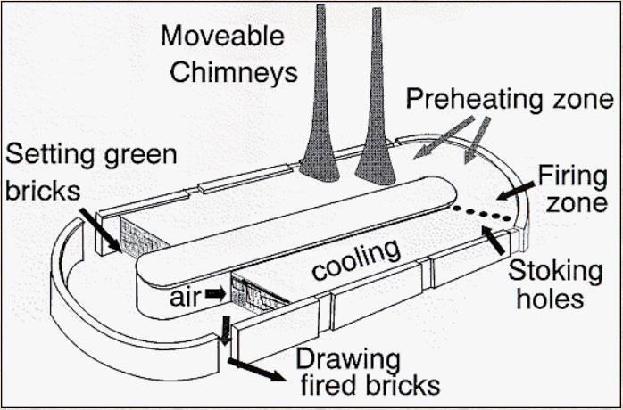

**Fig. 3.7 Bull's Trench Kilns**

### 3.2 EXISTING SYSTEM

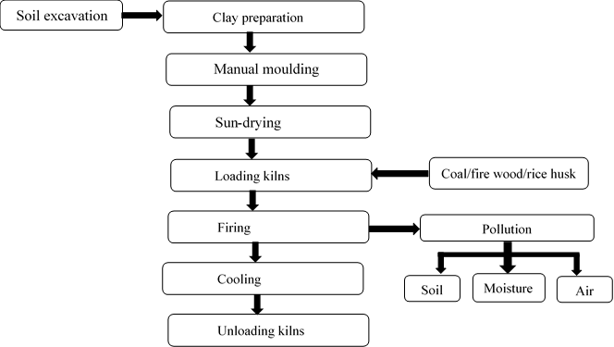

**Fig. 3.8 Existing System**

### 3.3 CAUSES

**Table 3.1 Causes of Existing System**

|  |  |  |  |  |  |
| --- | --- | --- | --- | --- | --- |
| **Methods of kilns** |  | **Emission factor (g/kg of fired brick)** | | |  |
| **SPM** | **PM2.5** | **SO2** | **CO** | **CO2** |
| **FCBTK** | 0.86 | 0.18 | 0.66 | 2.25 | 115 |
| **Zig-Zag** | 0.26 | 0.13 | 0.32 | 1.47 | 103 |
| **VSBK** | 0.11 | 0.09 | 0.54 | 1.84 | 70 |
| **DDK** | 1.56 | 0.97 | 1.47 | 5.78 | 282 |
| **TUNNEL** | 0.31 | 0.18 | 0.72 | 2.45 | 166 |

### 3.4 DISADVANTAGES

* Over 1,072 million tons of carbon dioxide are emitted into the atmosphere each year by kilns, or 2.7% of all emissions. Black carbon from thousands of kilns at Tran's boundary directly contributes to glacier melting in the Himalayas and modifies monsoon rainfall patterns.
* Annual coal consumption by brick kilns around the world is 375,000,000 tons.
* High mortality rates from respiratory diseases among local residents and workers.
* Negative effects on agriculture, including decreased agricultural yields and food security. Wheat and rice harvests are particularly vulnerable.
* A decline in biodiversity.
* Traditional brick kilns demand a lot of labor and take a long time to operate. In addition, brick production is expensive. Even though doing all of this lowers brick quality.
* There is more possibility to get a loss on bricks while burning the bricks if it is not burnt properly.

### 3.5 PROPOSED SYSTEM

In the proposed system electricity is used for kiln the brick. In detail show in bellow.

**Electric kilns:**

The major challenge in the brick industry is the environmental impact of conventional kilns, which consume large amounts of wood and emit harmful pollutants into the air, soil, and water. To address this issue, we propose an intelligent instant brick kiln machine that uses electricity instead of wood to heat and cures the bricks. This machine has several advantages over traditional kilns, such as:

* It reduces the carbon footprint and greenhouse gas emissions of the brick production process.
* It saves time and labor costs by automating the brick-making and curing process.
* It improves the quality and consistency of the bricks by using sensors and feedback mechanisms to control the temperature and humidity levels.
* It allows for greater flexibility and customization of the brick shapes and sizes by using a modular design and interchangeable molds.
* The intelligent instant brick kiln machine is a novel and eco-friendly solution that can revolutionize the brick industry and contribute to sustainable development.
* One of the most advanced and efficient methods of brick-making is the use of automation technology in the kiln process. This technology involves placing the raw bricks in a closed chamber that emits a high amount of heat radiation, which hardens and strengthens the bricks. The chamber is controlled by a computer program that automatically opens and closes the chamber door when the kiln cycle is completed.
* This reduces the manual labor and human error involved in the traditional kiln process and also saves energy and time. Automation technology is a smart and sustainable way of producing high-quality bricks for various construction purposes.

### 3.6 ADVANTAGES

* The instantly finished brick (to construct the wall) is possible.
* Zero emission of harmful gases. It will avoid contributing to global warming and polluting the atmosphere.
* It is also kilned the less quantity of bricks.
* Deforestation can be reduced (zero).
* Less manpower is required and also it will protect from disease

(cancer, infection, and respiratory)

* All-time (all seasons) production is possible.
* Less space is required for kilns.
* There are Agricultural impacts – damaging soil, crop production, and food security.
* There is no waste of bricks.

# CHAPTER 4

## DESIGN AND WORKING

### 4.1 Block diagram

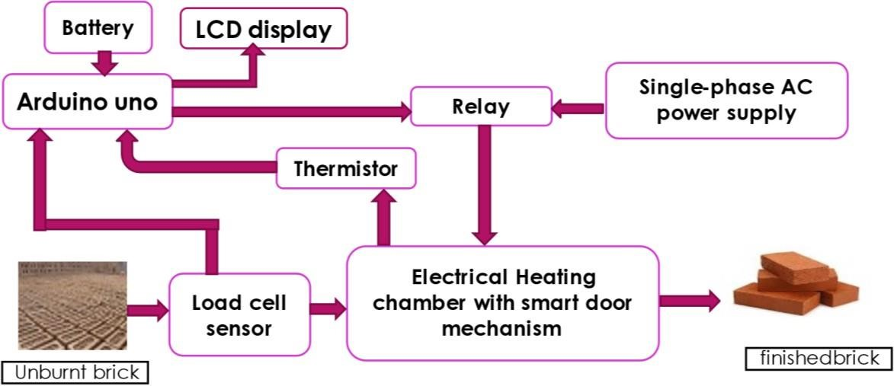

**Fig. 4.1 Proposed system block diagram**

#### a) AC power supply

* An AC power supply is a type of power supply used to supply alternating current (AC) power to the hole circuit.
* Here we are using the power supply which is used in domestic purpose i,e. single phase, 230v, 50Hz.

#### b) Relay

* A relay is an electrically operated switch. It consists of a set of input terminals for a single or multiple control signals, and a set of operating contact terminals.
* The switch may have any number of contacts in multiple contact forms, such as make contacts, break contacts, or combinations thereof.

#### c) LCD display

* liquid-crystal display (LCD) is a flat-panel display or other electronically modulated optical device that uses the light-modulating properties of liquid crystals combined with polarizers.
* Liquid crystals do not emit light directly but instead use a backlight or reflector to produce images in color or monochrome.

#### d) Arduino

* Arduino is an open-source electronics platform based on easy-to-use hardware and software.
* Arduino boards are able to read inputs - light on a sensor, a finger on a button, or a Twitter message - and turn it into an output - activating a motor, turning on an LED, publishing something online.

#### e) Thermistor

* A thermistor is a resistance thermometer, or a resistor whose resistance is dependent on temperature. The term is a combination of “thermal” and

“resistor”.

* It is made of metallic oxides, pressed into a bead, disk, or cylindrical shape and then encapsulated with an impermeable material such as epoxy or glass. **f) Load cell**

* It converts an input mechanical force such as load, weight, tension, compression, or pressure into another physical variable, in this case, into an electrical output signal that can be measured, converted and standardized.
* As the force applied to the sensor increases, the electrical signal changes proportionally.

#### g) Electrical Heating chamber

➢ Heat Chambers are used for gentle, temperature accurate thermal treatment of components in the area of electronic power controller production. Inert-gas atmosphere supports this process.

#### h) Non burnt clay brick

* It is a raw brick which contains moisture and with poor mechanical strength.

* Initial it is kept under the sun light to convert wet brick to semi dry brick. Here this semi dry brick is input to the heat chamber.

#### i) Burnt clay brick

* It is the finished brick which is completely burnt and came from the heating chamber also it having high mechanical strength compare to semi dry brick.
* It can be directly used to construct the walls.

#### 4.2 WORKING

* we will describe the process of making finished bricks from dry bricks using a heating chamber. The steps are as follows:
* Firstly, we are going to pick the dry bricks from the brick farming area. These are the bricks that have been molded and dried in the sun, but not yet fired.
* The particular bricks are placed on the load cell to check the weight of the bricks. This is important because the weight of the bricks determines the amount of heat and time required for firing them.
* Based on the weight of each brick is coded with particular timings for various classifications and the code is dumped into the Arduino UNO. If the brick weight is high, the heat timing in the chamber also increases and vice versa. The Arduino UNO is a microcontroller that controls the heating chamber according to the code.
* After the load cellular process, the dry bricks are placed inside the heating chamber for further process heating. From now, we are going to turn on the heating chamber with the single-phase AC supply. The heating chamber is an electric kiln that can reach high temperatures for firing bricks.
* After switching ON the heating chamber, the heat rises to 1000 degree Celsius from the initial stage. The accurate bricks can get at 1000 degree Celsius. This is the optimal temperature for making strong and durable bricks.
* The chamber is made up of copper coils. The copper coils are wounded around the heating chamber for equal emission of heat in the chamber. The copper coils are heated by electric current and transfer heat to the bricks inside.
* In the heating chamber inside part is constructed with Aluminum sheets for equal emission of heat in the chamber. The Aluminum sheets are emitting heat on every side in an equal manner. These sheets provide the accurate heating of the bricks process in the chamber. The aluminum sheets also reflect heat to the bricks and prevent heat loss.
* The Aluminum sheets play a major role in the heating process. Due to the equal emission of heat on every side of the chamber, the bricks are fired evenly and uniformly, without any cracks or defects.
* The brick is heated for a particular time based on its weight. The timing varies from 10 minutes to 30 minutes depending on the size and density of the brick. The longer the brick is heated, the harder and stronger it becomes.
* After the emission of 1000 degree Celsius of heat in the chamber. The brick absorbs the heat and will remove the moisture content in the bricks finally, the mechanical strength of the brick increase and we get the finished brick at the output. The finished brick is then removed from the chamber and cooled down before being stored or used.
* This is how we make finished bricks from dry bricks using a heating **intelligent instant brick kilns machine.**

#### 4.3 FLOW CHART

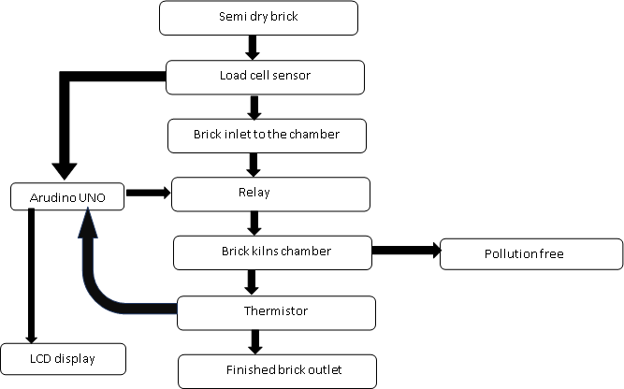

**Fig. 4.2 Flow Chart Proposed System**

#### 4.4 POLLUTION CAUSED BY VARIOUS METHODS OF KILNS

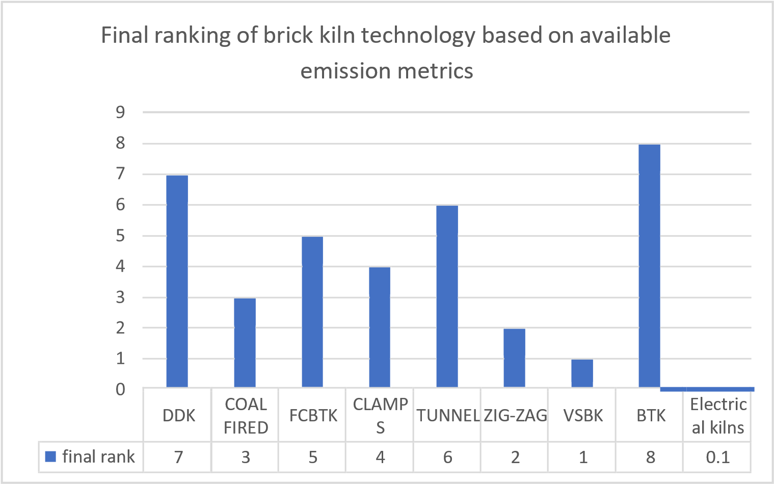

**Fig. 4.3 Pollution Caused By Various Methods Of Kilns**

#### 4.5 ADVANTAGES

* The instantly finished brick (to construct the wall) is possible.

* Zero emission of harmful gases. It will avoid contributing to global warming and polluting the atmosphere.
* It is also kilning the less quantity of bricks.

* Deforestation can be reduced(zero).

* Less manpower is required.

* All-time (all seasons) production is possible.

* Less space is required for kilns.

* There is Agricultural impacts – damaging soil, crop production and food security.
* There is no waste of brick

## CHAPTER 5

### HARDWARE DEVELOPMENT AND TESTING

#### 5.1 COMPONENTS AND SPECIFICATIONS

##### 5.1.1 Arduino

* The Arduino UNO is the voguish board to get started with electronics and pictures. 
* The UNO is the most accustomed and proven board of the whole Arduino family. 
* Arduino UNO SMD is a microcontroller board resting on the ATmega328P. 
* It contains 6 analog inputs, a 16 MHz ceramic resonator, 14 digital input/ affair legs (of which 6 may be used as PWM laborers), a USB harborage, a reset button, an ICSP title, and a power jack. 
* It comes with everything demanded to support the microcontroller; to use it, just plug in a USB string, an AC-DC accessory, or a battery to power it. 
* The" SMD" stands for the face-mount device, and the microcontroller (ATmega328p) is soldered directly to the board. 

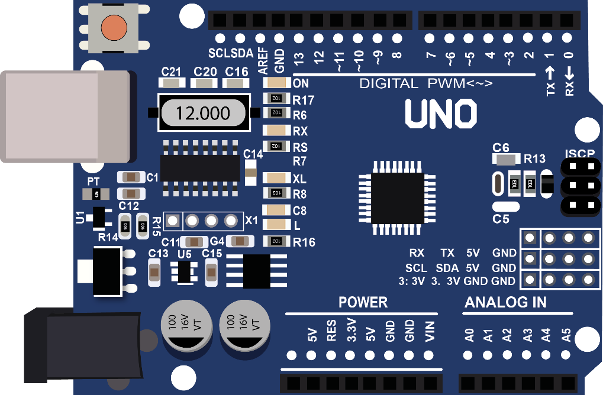

**Fig. 5.1 Arduino UNO R3 SMD**

**Table 5.1 Arduino UNO R3 SMD**

|  |  |  |
| --- | --- | --- |
| Board | Name | Arduino UNO R3 SMD |
| SKU | A000073 |
| Microcontroller | ATmega328P | |
| USB connector | USB-B | |
| Pins | Built-in LED Pin | 13 |
| Digital I/O Pins | 14 |
| Analog input pins | 6 |
| PWM pins | 6 |
| Communication | UART | Yes |
| I2C | Yes |
| SPI | Yes |
| Power | I/O Voltage | 5V |
| Input voltage (nominal) | 7-12V |
| DC Current per I/O Pin | 20 mA |
| Power Supply  Connector | Barrel Plug |
| Clock speed | Main Processor | ATmega328P 16 MHz |
| USB-Serial Processor | ATmega16U2 16 MHz |
| Memory | ATmega328P | 2KB SRAM, 32KB FLASH,  1KB EEPROM |
| Dimensions | Weight | 25 g |
| Width | 53.4 mm |
| Length | 68.6 mm |

The Arduino uno is a microcontroller board based on the ATmega. It has 54 digital input/output pins (of which 14 can be used as PWM outputs), 16 analog inputs, 4 UARTs (hardware serial ports), a 16 MHz crystal oscillator, a USB connection, a power jack, an ICSP header, and a reset button. It contains everything needed to support the microcontroller; simply connect it to a computer with a USB cable or power it with a AC-to-DC adapter or battery to get started.

**5.1.2 Power**

The Arduino Mega can be powered via the USB connection or with an external power supply. The power source is selected automatically. External (non-USB) power can come either from an AC-to-DC adapter (wall-wart) or battery. The adapter can be connected by plugging a 2.1mm center-positive plug into the board's power jack. Leads from a battery can be inserted in the Gnd and Vin pin headers of the POWER connector. The board can operate on an external supply of 6 to 20 volts. If supplied with less than 7V, however, the 5V pin may supply less than five volts and the board may be unstable. If using more than 12V, the voltage regulator may overheat and damage the board. The recommended range is 7 to 12 volts. The Mega2560 differs from all preceding boards in that it does not use the FTDI USB-to-serial driver chip. Instead, it features the Atmega8U2 programmed as a USB-to-serial converter.

**5.1.3 Power Pins:**

* **VIN.** The input voltage to the Arduino board when it's using an external power source (as opposed to 5 volts from the USB connection or other regulated power source). You can supply voltage through this pin, or, if supplying voltage via the power jack, access it through this pin.
* **5V.** The regulated power supply used to power the microcontroller and other components on the board. This can come either from VIN via an on-board regulator, or be supplied by USB or another regulated 5V supply.
* **3V3.** A 3.3 volt supply generated by the on-board regulator. Maximum current draw is 50 mA.
* **GND.** Ground pins.

**5.1.4 Memory**

The ATmega2560 has 256 KB of flash memory for storing code (of which 8 KB is used for the bootloader), 8 KB of SRAM and 4 KB of EEPROM (which can be read and written with the EEPROM library).

**5.1.5 Input and Output**

Each of the 54 digital pins on the Mega can be used as an input or output, using pinMode(), digitalWrite(), and digitalRead() functions. They operate at 5 volts. Each pin can provide or receive a maximum of 40 mA and has an internal pull-up resistor (disconnected by default) of 20-50 kOhms. In addition, some pins have specialized functions:

**Serial: 0 (RX) and 1 (TX); Serial 1: 19 (RX) and 18 (TX); Serial 2: 17 (RX) and 16 (TX); Serial 3: 15 (RX) and 14 (TX).** Used to receive (RX) and transmit (TX) TTL serial data. Pins 0 and 1 are also connected to the corresponding pins of the ATmega8U2 USB-to-TTL Serial chip.

**External Interrupts: 2 (interrupt 0), 3 (interrupt 1), 18 (interrupt 5), 19 (interrupt 4), 20 (interrupt 3), and 21 (interrupt 2).** These pins can be configured to trigger an interrupt on a low value, a rising or falling edge, or a change in value. See the attachInterrupt() function for details.

**PWM: 0 to 13.** Provide 8-bit PWM output with the analogWrite() function.

**SPI: 50 (MISO), 51 (MOSI), 52 (SCK), 53 (SS).** These pins support SPI communication using the SPI library. The SPI pins are also broken out on the ICSP header, which is physically compatible with the Uno, Duemilanove and Diecimila.

**LED: 13.** There is a built-in LED connected to digital pin 13. When the pin is HIGH value, the LED is on, when the pin is LOW, it's off.

**I2C: 20 (SDA) and 21 (SCL).** Support I2C (TWI) communication using the Wire library (documentation on the Wiring website). Note that these pins are not in the same location as the I2C pins on the Duemilanove or Diecimila.

The Mega2560 has 16 analog inputs, each of which provide 10 bits of resolution (i.e. 1024 different values). By default they measure from ground to 5 volts, though is it possible to change the upper end of their range using the AREF pin and analog Reference() function.

**There are a couple of other pins on the board:**

**AREF.** Reference voltage for the analog inputs. Used with analog Reference(). **Reset.** Bring this line LOW to reset the microcontroller. Typically used to add a reset button to shields which block the one on the board.

**5.1.6 Communication**

The Arduino Mega2560 has a number of facilities for communicating with a computer, another Arduino, or other microcontrollers. The ATmega2560 provides four hardware UARTs for TTL (5V) serial communication. An ATmega8U2 on the board channels one of these over USB and provides a virtual com port to software on the computer (Windows machines will need a .inf file, but OSX and Linux machines will recognize the board as a COM port automatically. The Arduino software includes a serial monitor which allows simple textual data to be sent to and from the board. The RX and TX LEDs on the board will flash when data is being transmitted via the ATmega8U2 chip and USB connection to the computer (but not for serial communication on pins 0 and 1). A SoftwareSerial library allows for serial communication on any of the Mega2560's digital pins. The ATmega UNO also supports I2C (TWI) and SPI communication. The Arduino software includes a Wire library to simplify use of the I2C bus; see the documentation on the Wiring website for details. For SPI communication, use the SPI library.

**5.1.7 Programming**

The Arduino Mega can be programmed with the Arduino software (download). For details, see the reference and tutorials. The ATmega2560 on the Arduino Mega comes pre burned with a boot loader that allows you to upload new code to it without the use of an external hardware programmer. It communicates using the original STK500 protocol (reference, C header files). You can also bypass the bootloader and program the microcontroller through the ICSP (In-Circuit Serial Programming) header; see these instructions for details. The ATmega8U2 firmware source code is available in the Arduino repository. The ATmega8U2 is loaded with a DFU bootloader, which can be activated by connecting the solder jumper on the back of the board (near the map of Italy) and then resetting the 8U2. You can then use Atmel's FLIP software (Windows) or the DFU programmer (Mac OS X and Linux) to load a new firmware. Or you can use the ISP header with an external programmer (overwriting the DFU boot loader). See this user-contributed tutorial for more information.

**5.1.8 Automatic Reset**

Rather then requiring a physical press of the reset button before an upload, the Arduino Mega2560 is designed in a way that allows it to be reset by software running on a connected computer. One of the hardware flow control lines (DTR) of the ATmega8U2 is connected to the reset line of the ATmega2560 via a 100 nano-farad capacitor. When this line is asserted (taken low), the reset line drops long enough to reset the chip. The Arduino software uses this capability to allow you to upload code by simply pressing the upload button in the Arduino environment. This means that the bootloader can have a shorter timeout, as the lowering of DTR can be well-coordinated with the start of the upload. This setup has other implications. When the Mega2560 is connected to either a computer running Mac OS X or Linux, it resets each time a connection is made to it from software (via USB). For the following half-second or so, the boot loader is running on the Mega2560. While it is programmed to ignore malformed data (i.e. anything besides an upload of new code), it will intercept the first few bytes of data sent to the board after a connection is opened. If a sketch running on the board receives one-time configuration or other data when it first starts, make sure that the software with which it communicates waits a second after opening the connection and before sending this data. The Mega2560 contains a trace that can be cut to disable the auto-reset. The pads on either side of the trace can be soldered together to re-enable it. It's labeled "RESET-EN". You may also be able to disable the auto-reset by connecting a 110 ohm resistor from 5V to the reset line; see this forum thread for details.

**5.1.9 USB overcurrent protection**

The Arduino Mega2560 has a resettable poly fuse that protects your computer's USB ports from shorts and over current. Although most computers provide their own internal protection, the fuse provides an extra layer of protection. If more than 500 mA is applied to the USB port, the fuse will automatically break the connection until the short or overload is removed.

##### 5.2 Liquide Crystal Display (LCD)

* A flat-panel display or other electronically modulated optical system that makes use of polarizers and light-modulating liquid charger packets is known as a liquid-demitasse display (TV). 
* Liquid chargers do not directly emit light; instead, they use a backlight or piece of glass to produce colored or immediate images. 
* A 16x2 TV is a type of display device that can show alphanumeric characters and some symbols on a screen. 
* As the name suggests, it includes 16 Columns & 2 Rows so it can display 32 characters (16 × 2 = 32) in total & every character will be made with 5 × 8(40) Pixel Blotches. So, the total pixels within this TV can be calculated as 32 x 40 else 1280 pixels. 16 X2 displays substantially depend on multi-segment LEDs. 
* The parcels of liquid chargers which make them suitable for use in displays are; their capability to affect the path of aero-plane concentrated light and their response to changes in temperature. 
* Thermotropic liquid chargers are a type of liquid demitasse that reacts to changes in temperature. 
* The advantage of using a 16x2 TV is that it can display information in a clear and readable way, without consuming too important power or space. 
* It can also be connived with colorful microcontrollers and bias, similar as Arduino, Raspberry Pi, etc. 
* The 16x2 TV has a standard interface that consists of 16 legs, which are used to control the display functions and data transfer. 
* The legs are divided into two groups control legs and data legs. The control legs are used to shoot commands to the TV, similar to turning it on or out, setting the cursor position, clearing the screen, etc. 
* The data legs are used to shoot the factual characters or symbols to be displayed on the TV. 
* A 16x2 TV is a type of display device that can show alphanumeric characters and some symbols on a screen. It's generally used in colorful operations, similar as calculators, digital timepieces, electronic measures, etc. In this composition, we will learn how to affiliate a 16x2 TV with an Arduino board and display some textbook on it. 
* The 16x2 TV has two main corridor the TV module and the backlight. The TV module is responsible for displaying the characters and symbols on the screen, while the backlight provides illumination for better visibility. 

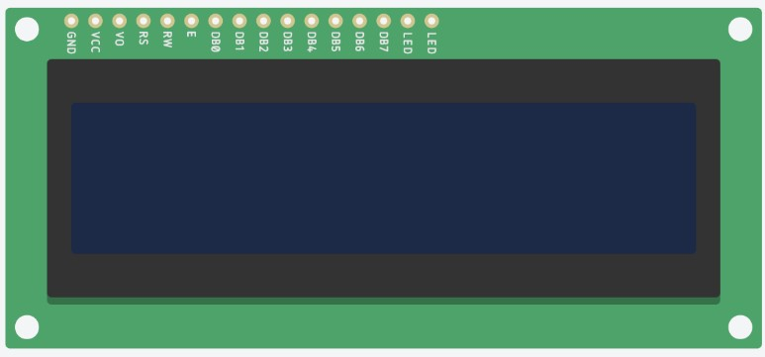

**Fig.5.2 LCD Display**

The LCD module has 16 pins that are used to connect it with the Arduino board.

The pins are labeled as follows:

* VSS: Ground pin
* VDD: Power supply pin (+5V)
* V0: Contrast adjustment pin
* RS: Register select pin
* RW: Read/write pin
* E: Enable pin
* D0-D7: Data pins
* A: Backlight anode pin
* K: Backlight cathode pin

The 16x2 LCD can operate in two modes: 4-bit mode and 8-bit mode. In the 4-bit mode, only four data pins (D4-D7) are used to transfer the data, while in the 8-bit mode, all eight data pins (D0-D7) are used.

The 4-bit mode requires fewer pins and is more efficient, while the 8-bit mode allows faster data transfer and more flexibility.

##### 5.3 Relay

* A relay is an electrically operated switch. Current flowing through the coil of the relay creates a glamorous field that attracts a switch and changes the switch connections. Relays feature two switch positions and are double gamble

(transfiguration) switches since the coil current can be on or off. 

* Relays allow one circuit to switch to an alternate circuit which can be fully separate from the first. As an example, a relay can switch a 230V AC mains circuit in a low-voltage battery circuit. There’s no electrical connection inside the relay between the two circuits; the link is glamorous and mechanical. 
* For a 12V relay, the coil typically passes a pretty significant amount of current, around 30mA, but for relays made to function at lower voltages, this current can be as significant as 100mA. Most Ic’s (chips) are unable to provide this current, so in most cases a transistor is employed to increase the little IC current to the higher value required for the relay coil. Since the popular 555 timekeeper IC’s maximum affair current is 200mA, this bias can directly power relay coils without modification. 
* Relays are generally SPDT or DPDT but they can have numerous further sets of switch connections, for illustration relays with 4 sets of transfiguration connections are readily available. For farther information about switch connections and the terms used to describe them please see the runner on switches. 
* The relay permits a small quantum of electrical current to control high-current loads. When voltage is supplied to the coil, a small current pass through the coil, performing in a larger quantum of current passing through the connections to control the electrical cargo. 
* As they enable the control of a high current inflow circuit by a low current inflow circuit, 
* 12V DC relay switches are the fashionable solution for full voltage operations. 

**12V SPDT Relay Specifications:**

* Trigger Voltage (Voltage across coil): 12V DC
* Trigger Current (Nominal current): 100mA
* Maximum AC load current: 7A @ 250/125V AC
* Maximum DC load current: 10A @ 30/28V DC
* Maximum switching: 300 operating/minute (mechanically)
* This 4-Channel Relay interface board enables you to manage a variety of appliances and other high-current devices. Micro-controllers (AVR, PIC, DSP, ARM, ARM, MSP430, and TTL logic) can directly control it. Specifications: 4-Channel Relay interface board, and each one needs 15-20mA Driver Current. 
* both powered by input voltages of 12V and 5V. 
* High-current relay AC250V 10A and DC30V 10A are included. 
* The interface is standard and can be directly controlled by a microcontroller. 
* Opto-isolated inputs for PIC, DSP, ARM, ARM, MSP430, and TTL logic active low. 
* Indication LEDs for Relay output status. 

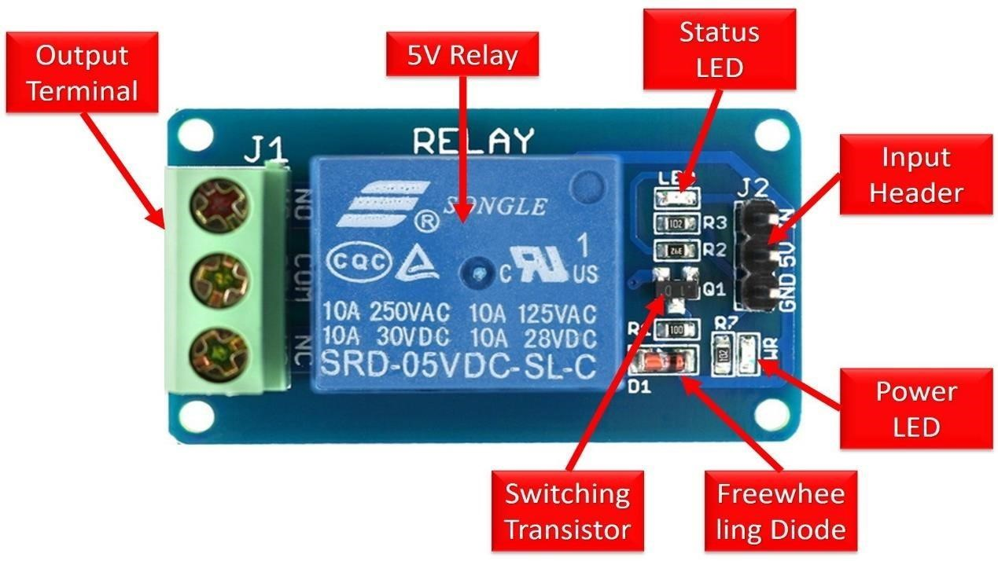 **Fig. 5.3 relay**

**5.3 Principle:**

It works on the principle of electromagnetism. The electromagnetic field that creates the temporary magnetic field is created when the relay’s circuit detects the fault current. The relay armature is moved by this magnetic field to open or close connections. An electromagnet is modified into a straightforward electromagnetic relay, like the one removed from an automobile in the first image. A moving iron armature, an iron yoke that acts as a low-reluctance channel for magnetic flux, a coil of wire encircling a soft iron core, and a pair, or sets, of contacts, in this case two in the relay shown. A moving contact or contacts are mechanically connected to the armature, which is hinged to the yoke.

It is secured in place by a spring so that there is an air gap in the magnetic circuit when the relay is de-energized. One of the two sets of contacts in the relay shown in this situation is closed, while the other set is open. Depending on how they are used, other relays may have more or fewer sets of connections. Additionally, the relay in the image has a wire joining the armature to the yoke. In doing so, the yoke, which is attached to the PCB, maintains circuit continuity between the moving contacts on the armature and the circuit track.

A connection between a moveable contact or contacts and a fixed contact is made or broken when an electric current flows through the coil, creating a magnetic field that pulls the armature. The movement opens the contacts and breaks the connection if the set of contacts was closed when the relay was de-energized, and the opposite is true if the connections were active. The armature is returned to its relaxed state by a force that is roughly half as strong as the magnetic force when the current to the coil is shut off. Gravity is also frequently 35energize in industrial motor starters, but a spring is typically employed to produce this force. The majority of relays are made to operate quickly. This lowers noise in a low-voltage application. This is done to lessen arcing in a high voltage or high current application.

In order to dissipate the energy from the collapsing magnetic field upon deactivation, which would otherwise cause a voltage spike hazardous to circuit components, a diode is typically put across the coil if the coil is 35energized with DC. That diode is already included in some automobile relays within the relay housing. As an alternative, the surge may be absorbed by a contact protection network made of a capacitor and a resistor connected in series. A little copper ring can be crimped onto the end of the solenoid if the coil is intended to be powered by AC. The “shading ring” improves the minimum pull on the armature during the AC cycle by producing a tiny out-of-phase current. A thruster or other solid-state switching device is used to create a solid-state relay by analogy with the operations of the original electromagnetic device. An optocoupler, which consists of an LED linked with a phototransistor, can be used to achieve electrical isolation.

##### 5.5 Load cell

A cargo cell (loadcell) is a transducer that converts force into a measurable electrical affair. Although there are numerous kinds of force detectors, strain hand cargo cells are the most generally used type. Except for certain laboratories where perfect mechanical balances are still used, strain hand cargo cells dominate the importing assiduity. Curvaceous cargo cells are occasionally used where natural safety and hygiene are asked, and hydraulic cargo cells are considered in remote locales, as they don't bear a power force. Strain hand cargo cells offer rigor from within0.03 to0.25 full scale and are suitable for nearly all artificial operations.

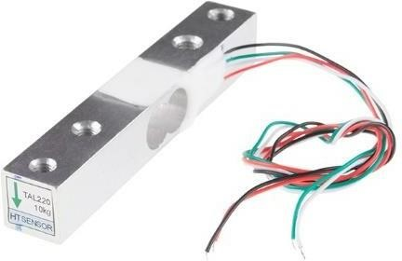

**Fig. 5.4 load cell**

**How does a cargo cell work?**

A cargo cell workshop by converting mechanical force into digital values that the stoner can read and record. The inner working of a cargo cell differs grounded on the cargo cell that you choose. There are hydraulic cargo cells, curvaceous cargo cells, and strain hand cargo cells. Strain hand cargo detectors are the most generally used among the three. Strain hand cargo cells contain strain needles within them that shoot up voltage irregularities when under cargo. The amount of voltage change is represented by weight in a digital reading.

**5.6 Load Cell Types:**

cargo cell designs can be distinguished according to the type of affair signal generated (curvaceous, hydraulic, electric) or according to the way they descry weight (bending, shear, contraction, pressurize).

**Hydraulic load cells:**

replica cargo cell Hydraulic cells have a tendency towards force-balance and measure weight as a change in the internal stuffing fluid's pressure. In a rolling diaphragm type hydraulic force detector, a cargo or force acting on a lading head is transferred to a piston that in turn compresses a filling fluid confined within an elastomeric diaphragm chamber. As force increases, the pressure of the hydraulic fluid increases. This pressure can be locally indicated or transmitted for remote suggestion or control. Affair is direct and fairly innocent by the quantum of the filling fluid or by its temperature. However, delicacy can be within 0, If the cargo cells have been duly installed and calibrated.25 full scale or better, respectable for utmost process importing operations. Because this detector has no electric factors, it's ideal for use in dangerous areas. Typical hydraulic cargo cell operations include tank, caddy, and hopper importing. For maximum delicacy, the weight of the tank should be attained by locating one force detector at each point of support and casting their labor.

**Curvaceous cargo cells:**

Curvaceous cargo cells also operate on the force-balance principle. These biases use multiple dampener chambers to give advanced delicacy than can a hydraulic device.

The first dampener chamber may double as a tare weight chamber in some systems.

Curvy cargo chambers are widely used in diligence where cleanliness and safety are of utmost importance to measure relatively little weight.

**Pneumatic load cells:**

Pneumatic load cells also operate on the force-balance principle. These biases use multiple dampener chambers to give advanced delicacy than can a hydraulic device. The first dampener chamber may double as a tare weight chamber in some systems.

Curvy cargo chambers are widely used in diligence where cleanliness and safety are of utmost importance to measure relatively little weights.

The advantages of this type of cargo cell include their being innately explosion evidence and asleep to temperature variations. also, they contain no fluids that might pollute the process if the diaphragm ruptures. Disadvantages include fairly slow speed of response and the need for clean, dry, regulated air or nitrogen.

**Strain- hand cargo cell:**

Strain hand cargo cells are a type of cargo cell where a strain hand assembly is deposited inside the cargo cell casing to convert the cargo acting on them into electrical signals. The weight on the cargo cell is measured by the voltage change caused in the strain hand when it undergoes distortion. The needles themselves are clicked onto a ray or structural member that deforms when weight is applied. ultramodern cargo cells have 4 strain needles installed within them to increase the dimension delicacy. Two of the needles are generally in pressure, and two in contraction, and are wired with compensation adaptations. When there's no cargo on the cargo cell, the resistances of each strain hand will be the same. still, when under cargo, the resistance of the strain hand varies, causing a change in affair voltage. The change in affair voltage is measured and converted into readable values using a digital cadence.

#### Piezoresistive cargo cell

analogous in operation to strain needles, piezoresistive force detectors induce a high position affair signal, making them ideal for simple importing systems because they can be connected directly to a readout cadence. The vacuity of low cost direct amplifiers has lowered this advantage, still. An added debit of piezoresistive bias is their nonlinear affair.

##### 5.1.5 Thermistor

A resistance thermometer or a resistor whose resistance changes with temperature is a thermistor. The term is a combination of “thermal” and “resistor”. It's made of metallic oxides, pressed into a blob, fragment, or spherical shape and also reprised with an impermeable material similar as epoxy resin or glass.

Thermistors come in two varieties: negative temperature counters (NTC) and positive temperature counters (PTC). When the temperature rises, an NTC thermistor's resistance decreases. Again, when temperature diminishments, resistance increases. The most common thermistor type is this one.

A PTC thermistor works a little else. When the temperature rises, the resistance rises, and when the temperature falls, the resistance falls. The usual application for this kind of thermistor is as a fuse. Generally, a thermistor achieves high perfection within a limited temperature range of about 50ºC around the target temperature. The base resistance determines this range.

**The thermistor symbols are:**

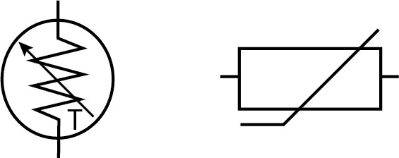

**Fig. 5.5 Symbol of Thermistor**

The arrow next to the T denotes that the resistance is temperature-dependent and variable. The direction of the arrow or bar isn't significant.

Thermistors are easy to use, affordable, sturdy, and respond predictably to changes in temperature. While they don't work well with exorbitantly hot or cold temperatures, they're the detector of choice for operations that measure temperature at an asked base point. They're ideal when veritably precise temperatures are needed.

Thermistors are frequently used in digital thermometers, in buses to measure the temperatures of coolants and oil paintings, and in household appliances like ovens and refrigerators. refrigerators, but they're also set up in nearly any operation that requires heating or cooling protection circuits for safe operation. The thermistor is included in for more complex processes such as charge-linked bias, optic blocks, and ray stabilization sensors. As an example, the standard that is built into raypackages is a 10k thermistor.

**How Does the Thermistor “Read” Temperature?**

A thermistor doesn't actually “read” anything, rather the resistance of a thermistor changes with temperature. The thermistor's material composition determines how much the resistance varies.

Unlike other detectors, thermistors are nonlinear, meaning the points on a graph representing the relationship between resistance and temperature won't form a straight line. The thermistor's design determines where the line is and how significantly it changes. A typical thermistor graph looks like this.

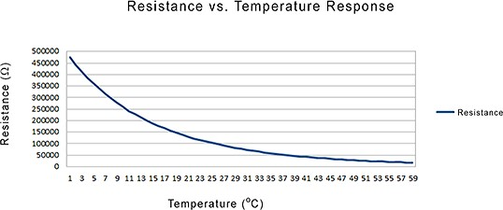

**Fig.5.6 Resistance vs. Temperature**

Below, it will be discussed in more detail how the resistance change is translated into quantifiable statistics.

Range of temperatures the general temperature range in which a detector type can be applied. Within a given temperature range, some detectors work better than others.

Relative Cost Relative cost as these detectors is compared to one another. For instance, thermistors are cheaper than RTDs, in part because platinum is the preferred material for RTDs.

Time Constant Approximate time needed to change fromone temperature value to another. This is the amount of time, in seconds, that a thermistor needs to travel from its first measurement to the end bone's temperature difference of 63.2 degrees.

Stability The capability of a regulator to maintain a constant temperature grounded on the detector’s temperature feedback. perceptivity the degree of response to a change in temperature.

**Which Thermistor Shapes Are Available?**

Thermistors can be face mounted or bedded in a system and come in a range of forms, including fragment, chip, blob, and rod. They can be reprised in epoxy resin, glass, ignited- on phenolic, or painted. The stylish shape frequently depends on what material is being covered, similar as a solid, liquid, or gas.

For illustration, a blob thermistor is ideal for bedding into a device, while a rod, fragment, or spherical head are stylish for optic shells. A thermistor chip is typically mounted on a published circuit board (PCB). There are numerous, numerous different shapes of thermistors and some exemplifications are

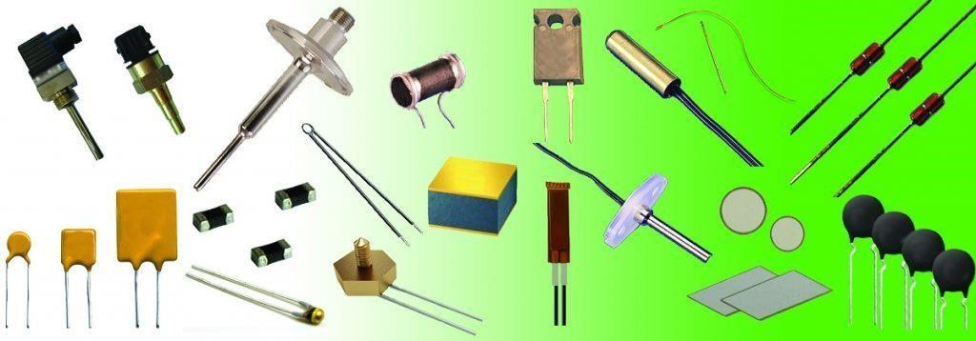

**Fig. 3.7 Thermistor Types**

Pick a form that permits your face to have the most contact with the appliance whose temperature you are covering. Anyhow of the type of thermistor, the connection to the covered device must be made using a largely thermally conductive paste or epoxy resin cement. It's generally important that this paste or cement isn't electrically conductive.

**How Does a thermistor Work in A Controlled System?**

A thermistor's primary function is to gauge a device's internal temperature. The thermistor is a minor but crucial component of a bigger system in a temperature- controlled system. A temperature regulator monitors the temperature of the thermistor. Additionally, it instructs a heater or cooler when to switch on or off in order to maintain the detector's temperature.

In the illustration below, illustrating an illustration system, there are three main factors used to regulate the temperature of a device the temperature detector, the temperature regulator, and the Peltier device (labeled then as a TEC, or thermoelectric cooler). The cables are joined to the temperature regulator, and the detector head is coupled to the cooling plate, which must maintain a particular temperature to cool the apparatus. Additionally, the Peltier device, which heats and cools the target device, is electronically coupled to the temperature regulator. The Peltier gadget has a heatsink mounted to it to aid with heat dispersion.

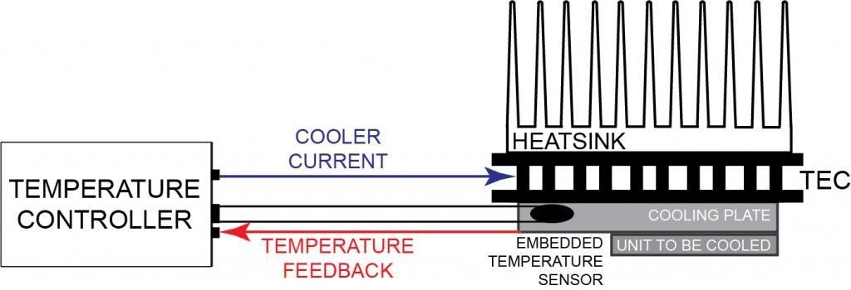

**Fig. 5.8 Thermistor Controlled System**

The job of the temperature detector is to shoot the temperature feedback to the temperature regulator. The detector has a small quantum of current running through it, called bias current, which is transferred by the temperature regulator. The regulator can’t read resistance, so it must convert resistance changes to voltage changes by using a current source to apply a bias current across the thermistor to produce a control voltage.

The temperature regulator is the smart of this operation. It takes the detector information, compares it to the unit to be cooled requirements (called the setpoint), and adjusts the current through the Peltier device to change the temperature to match the setpoint.

The position of the thermistor in the system affects both the stability and the delicacy of the control system. For stylish stability, the thermistor needs to be placed as close to the thermoelectric or resistive heater as possible. For stylish delicacy, the thermistor needs to be located near to the device taking temperature control. immaculately, the thermistor is bedded in the device, but it can also be attached using thermally conductive paste or cement. In deed if a device is bedded, air gaps should be excluded using thermal paste or cement.

The figure below shows two thermistors, one attached directly to the device and one remote, or distant from the device. However, thermal pause time significantly reduces the delicacy of the temperature dimension, while placing the thermistor too far from the

Peltier device reduces the stability, If the detector is too far down from the device

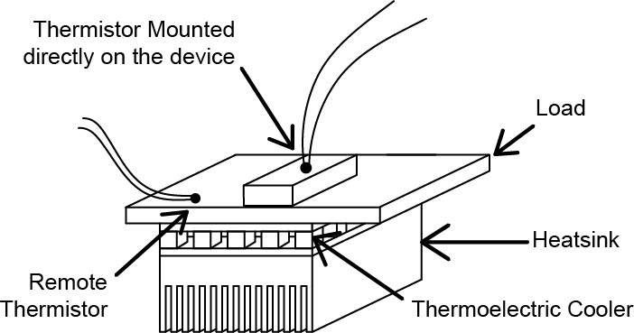

**Fig. 5.8 Thermistor Placement**

The graph in the next figure shows how the temperatures recorded by the two thermistors differ. The device's thermistor responded quickly to changes in thermal payload and captured precise temperatures. The remote thermistor also replied but not relatively as snappily. More importantly, the readings are out by a little further than half a degree. This difference can be veritably significant when accurate temperatures are needed.

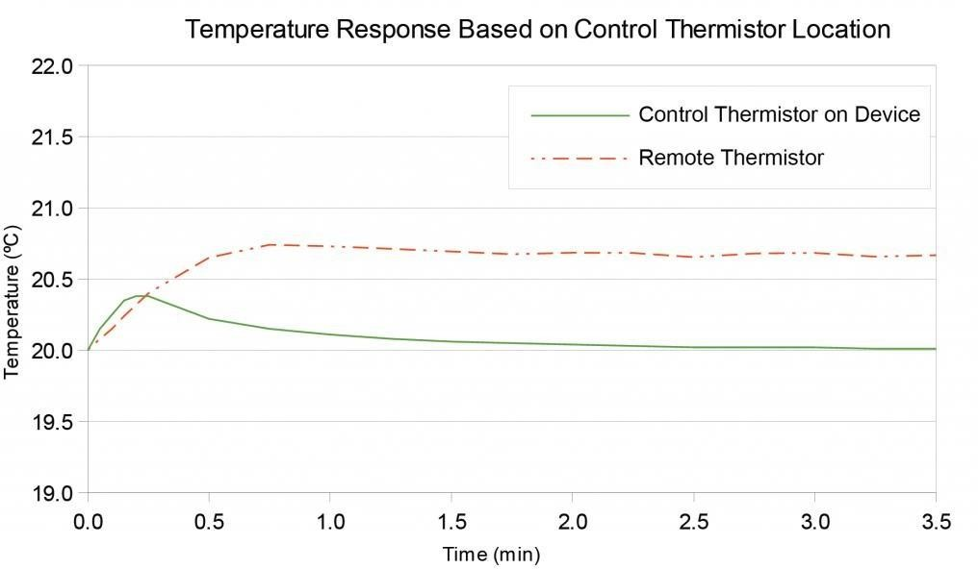

**Fig. 5.9 Thermistor Location Response Graph**

Once the placement of the sensor has been chosen, then the rest of the system needs to be configured. This includes determining the base thermistor resistance, the bias current for the sensor, and the setpoint temperature of the load on the temperature controller.

**What are the upper and lower voltage limits of the sensor input of the temperature controller?**

The voltage limits of the detector feedback to a temperature regulator are specified by the manufacturer. The optimal choice for a thermistor and bias current combination is one that generates a voltage within the temperature regulator's permitted range.

Ohm's Law relates voltage to resistance. The required bias current is calculated using this equation. According to Ohm's Law, with a bias current, the current through a circuit between two points is directly proportional to the implicit difference between the two sites. is written as

V = IBIAS x R...................... 5.1

Where:

V is voltage, in Volts(V)

IBIAS is the current, in Amperes or Amps(A)

IBIAS means the current is fixed

R is resistance, in Ohms(Ω)

To translate the thermistor resistance into a measurably higher voltage, the regulator generates a bias current. Only a limited range of voltages is acceptable for the regulator. For illustration, if a regulator range is 0 to 5 V, the thermistor voltage needs to be no lower than 0.25V so that low-end electrical noise doesn't intrude with the reading, and is not advanced than 5 V in order to be read.

Assume the use of the below regulator and a 100 kΩ thermistor, similar to

Wavelength’s TCS651 and the temperature the device needs to maintain is 20 °C. The resistance is 126700 at 20 °C, as stated in the TCS651 datasheet. To determine if the thermistor can work with the regulator, we need to know the usable range of bias currents. Using Ohm’s Law to break for IBIAS, we know the following

V/ R = IBIAS ....................................5.2

230/ 126700 = 2 µA is the smallest end of the range

230/ 126700 = 39.5 µA is the loftiest end

Yes, this thermistor will work, if the temperature regulator bias current can be set between 2 µA and39.5 µA.

When opting a thermistor and bias current, it's stylish to choose one where the voltage developed is in the middle of the range. The regulator feedback input needs to be in voltage, which is deduced from the thermistor resistance.

Since people relate to temperature most fluently, the resistance frequently needs to be changed to temperature. The Steinhart-Hart equation is the most precise model for converting thermistor resistance to temperature.

**What Is the Steinhart-Hart Equation?**

The Steinhart- Hart equation is a model that was developed at a time when computers weren't ubiquitous and utmost fine computations were done using slide rules and other fine aids, similar to transcendental function tables. The equation was created as a straightforward method for accurately and fluently simulating thermistor temperatures.

The Steinhart- Hart equation is

1/ T = A B(lnR) C(lnR) 2 D(lnR) 3 E(lnR) 4 ................ 5.3

Where:

T is temperature, in Kelvins (K, Kelvin = Celsius273.15)

R is resistance at T, in Ohms(Ω)

A, B, C, D, and E are the Steinhart- Hart portions that vary depending on the type of thermistor used and the range of temperature being detected.

ln is Natural Log, or Log to the Napierian base2.71828

The terms can go on infinitely but, because the error is so small, the equation is abbreviated after the cubed term and the squared term is excluded, so the standard

Steinhart- Hart equation used is this

T = A B(lnR) C(lnR) 3 ..................................... 5.4

One of the pleasures of computer programs is that equations that would have taken days, if not weeks, to break are done in moments. Type “Steinhart- Hart equation calculator” in any hunt machine and runners of links to online calculators are returned.

**5.7 Power Supply:**

The power supplies are designed to convert high voltage AC mains electricity to a suitable low voltage supply for electronics circuits and other devices. A power supply can by broken down into a series of blocks, each of which performs a particular function. A d.c power supply which maintains the output voltage constant irrespective of a.c mains fluctuations or load variations is known as “Regulated D.C Power Supply” For example a 5V regulated power supply system as shown below:

**5.8 Transformer:**

A transformer is an electrical device which is used to convert electrical power from one electrical circuit to another without change in frequency. Transformers convert AC electricity from one voltage to another with little loss of power. Transformers work only with AC and this is one of the reasons why mains electricity is AC. Step-up transformers increase in output voltage, step-down transformers decrease in output voltage. Most power supplies use a step-down transformer to reduce the dangerously high mains voltage to a safer low voltage. The input coil is called the primary and the output coil is called the secondary. There is no electrical connection between the two coils; instead they are linked by an alternating magnetic field created in the soft-iron core of the transformer. The two lines in the middle of the circuit symbol represent the core. Transformers waste very little power so the power out is (almost) equal to the power in. Note that as voltage is stepped down current is stepped up. The ratio of the number of turns on each coil, called the turn’s ratio, determines the ratio of the voltages. A step-down transformer has a large number of turns on its primary (input) coil which is connected to the high voltage mains supply, and a small number of turns on its secondary (output) coil to give a low output voltage.

**Capacitor Filter:**

We have seen that the ripple content in the rectified output of half wave rectifier is 121% or that of full-wave or bridge rectifier or bridge rectifier is 48% such high percentages of ripples is not acceptable for most of the applications. Ripples can be removed by one of the following methods of filtering.

(a) A capacitor, in parallel to the load, provides an easier by –pass for the ripples voltage though it due to low impedance. At ripple frequency and leave the d.c.to appears the load

(b) An inductor, in series with the load, prevents the passage of the ripple current (due to high impedance at ripple frequency) while allowing the d.c (due to low resistance to d.c)

(c) various combinations of capacitor and inductor, such as L-section filter section filter, multiple section filter etc. which make use of both the properties mentioned in (a) and (b) above. Two cases of capacitor filter, one applied on half wave rectifier and another with full wave rectifier

Filtering is performed by a large value electrolytic capacitor connected across the DC supply to act as a reservoir, supplying current to the output when the varying DC voltage from the rectifier is falling. The capacitor charges quickly near the peak of the varying DC, and then discharges as it supplies current to the output. Filtering significantly increases the average DC voltage to almost the peak value (1.4 × RMS value).

To calculate the value of capacitor(C),

C = ¼*√3*f*r*Rl

Where,

f = supply frequency,

r = ripple factor,

Rl = load resistance

**CHAPTER 6**

**SOFTWARE**

**6.1 Circuit Diagram:**

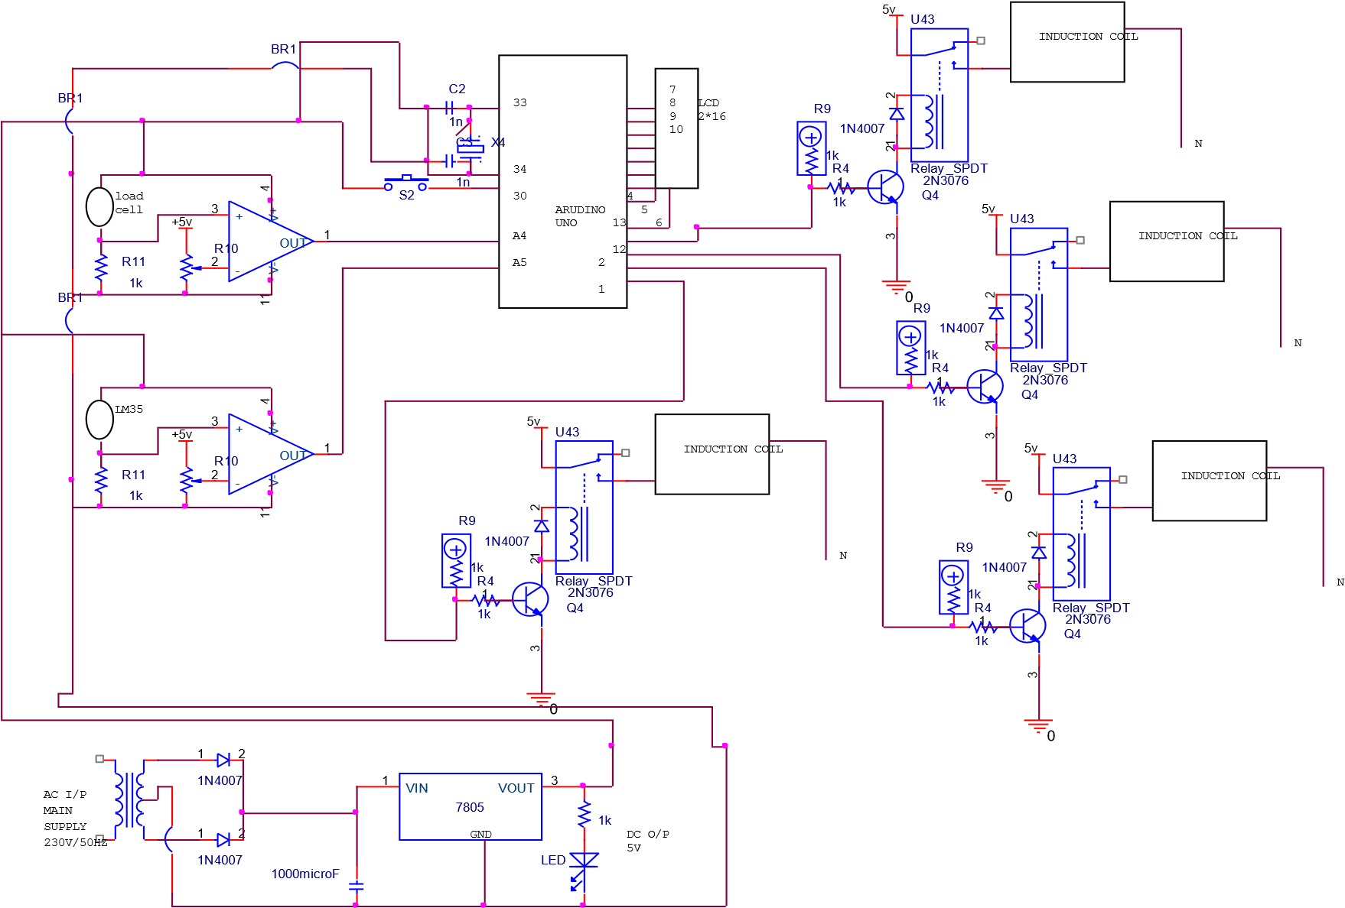

**Fig. 6.1 circuit diagram**

**6.2 Software Code:**

#include "HX711.h" //You must have this library in your arduino library folder

#define DOUT D5

#define CLK D6

HX711 scale(DOUT, CLK);

//Change this calibration factor as per your load cell once it is found you many need to vary it in thousands float calibration_factor = -109525; //-106600 worked for my 40Kg max scale setup

// SETUP void setup() { Serial.begin(9600);

Serial.println("HX711 Calibration");

Serial.println("Remove all weight from scale");

Serial.println("After readings begin, place known weight on scale");

Serial.println("Press a,s,d,f to increase calibration factor by 10,100,1000,10000 respectively");

Serial.println("Press z,x,c,v to decrease calibration factor by 10,100,1000,10000 respectively"); Serial.println("Press t for tare"); scale.set_scale(); scale.tare(); //Reset the scale to 0

long zero_factor = scale.read_average(); //Get a baseline reading

Serial.print("Zero factor: "); //This can be used to remove the need to tare the scale. Useful in permanent scale projects. Serial.println(zero_factor);

}

// LOOP void loop() {

scale.set_scale(calibration_factor); //Adjust to this calibration factor

Serial.print("Reading: ");

Serial.print(scale.get_units(), 3);

Serial.print(" kg"); //Change this to kg and re-adjust the calibration factor if you follow SI units like a sane person

Serial.print(" calibration_factor: ");

Serial.print(calibration_factor); Serial.println(); if(Serial.available())

{ char temp = Serial.read(); if(temp == '+' || temp == 'a') calibration_factor += 10; else if(temp == '-' || temp == 'z') calibration_factor -= 10; else if(temp == 's') calibration_factor += 100; else if(temp == 'x') calibration_factor -= 100; else if(temp == 'd') calibration_factor += 1000; else if(temp == 'c') calibration_factor -= 1000; else if(temp == 'f') calibration_factor += 10000; else if(temp == 'v') calibration_factor -= 10000; else if(temp == 't') scale.tare(); //Reset the scale to zero

**6.3 TEST RESULT:**

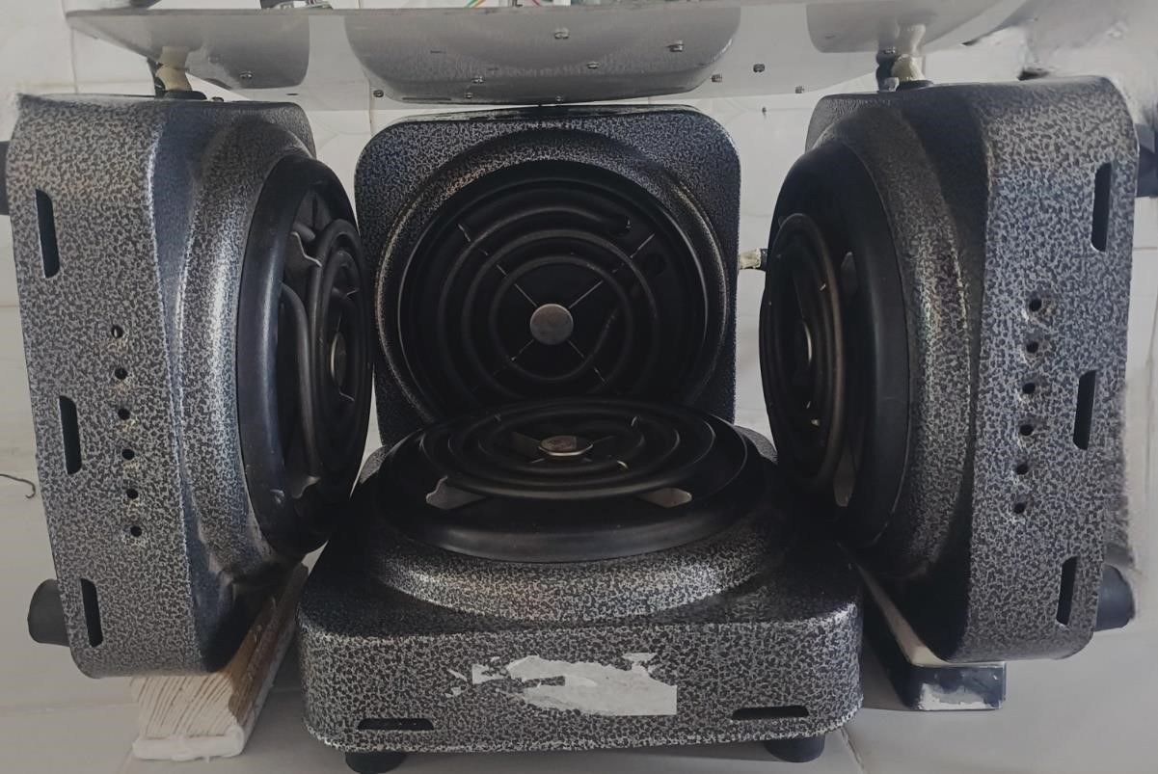

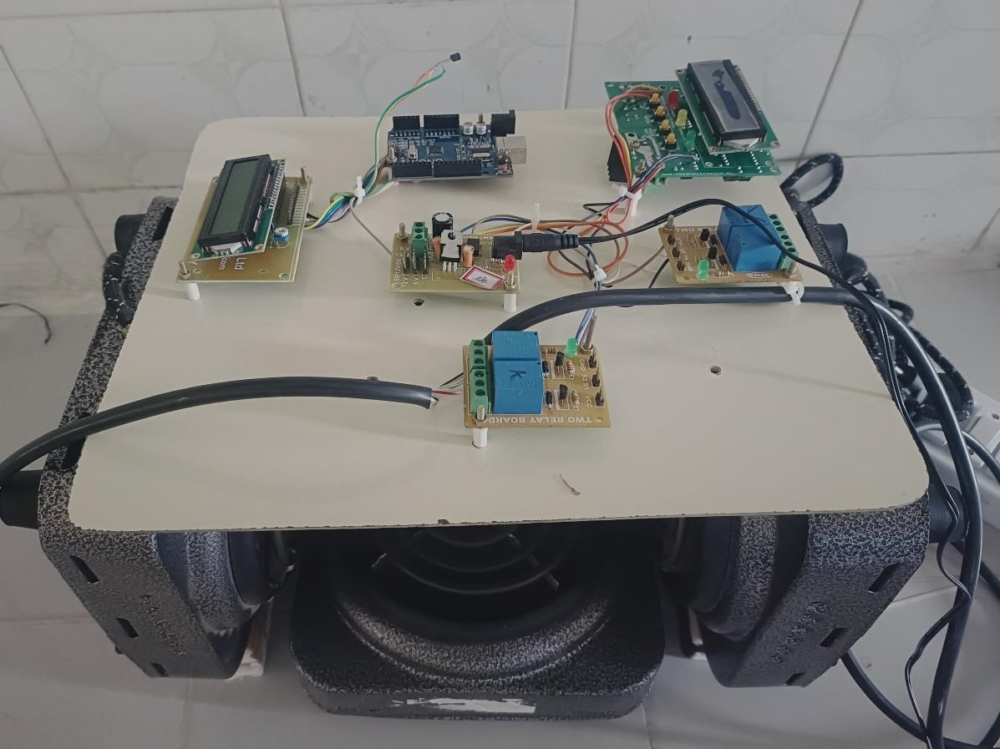

## CHAPTER 7

### CONCLUSION AND FUTURE SCOPES

From this project, we are concluding that optimizing the kiln process, this process doesn’t require a lot of manpower and natural resources, such as wood or coal. This system can ensure a uniform and efficient heating of the bricks, reducing energy consumption and the emissions of greenhouse gases. By implementing this system, we can achieve a more accurate and efficient method of brick kiln process, that can produce hard and strong bricks, without compromising the environment or human resources. Automation can also reduce the environmental impact and the health risks of the workers involved in the brick kilns process.

**Future scopes:**

* Our proposed solution is that it can be easily integrated with solar power generation which will reduce the electricity bill and also contribute to environmental sustainability. This system is reliable, efficient, and cost- effective, and we believe it will meet your needs and expectations.
* We can also implement monitoring and quality check of bricks (without any defects and cracks in the bricks).
* In the upcoming days, the proposed system can be established for the large production of bricks.
* We can also use this method for drying the wet brick by maintaining the required temperature within the chamber.

**REFERENCES:**

1. Proposal for Implementation of Induction Stoves for Electrification of the

Peruvian 00000Energy Matrix, Garay Aquino; Dennis Raul; Carlos Quispe Anccasi.

1. Automatic Room Temperature Control System Using Arduino UNO R3 and DHT11 Sensor, Gurmu M. Debele, Xiao Qian.
2. Arduino-based Automated Dosage Prescription using Load Cell, A. Rasheedha; K. Srinathi; T. Sivalavanya; R.R. Monesha.
3. Arduino-based Auto Door unlocks control system by Android mobile through

Bluetooth and Wi-Fi, M. Muthumari; Nitesh Kumar Sah; Rishu Raj; Jyotikinkar Saharia.

1. Linearization of NTC Thermistor Characteristic Using Op-Amp Based Inverting Amplifier, Aloke Raj Sarkar, Debangshu Dey, Sugata Munshi.
2. American Institute of Architects, Environmental Resource Guide, The American Institute of Architects, Canada, 1998.
3. Campbell, J. W. P. and Pryce, W., Brick, A World History, Thames and Hudson, New York, NY, 2003.
4. The Basics of Brick Kiln Technology, Jones, Tim, Aus der Arbeit von GATE, Vieweg, Braunschweig, 1995
5. Brick and Lime Kilns in Ecuador, Energy, Environment and Development

Series No. 13, The Stockholm Environmental Institute, Stockholm, 1992

1. Brick and Tile Making, Bender, W, & Händle, F., Bauverlag GmbH, Wiesbaden/ Berlin, 1982
2. Brickmaking in Developing Countries, Parry, J.P.M., Review prepared for the Building Research Establishment, Garston, U.K., 1979
3. Firing of Bull 's Trench Kilns, Majumdar, N.C., in Indian Builder, New Delhi, Sept.1957.
4. Guide for the design and manufacture of brick kilns, Indian Standards Institution, Doc. No. IS 4805-1968, New Delhi, 1968
5. The planning of brickworks, Bender, W., McDonald and Evans, Plymouth, 1978
6. The Self-Reliant Potter: Refractories and Kilns, Norsker, H., Vieweg, Braunschweig, 1987.
7. Small Scale Brickmaking, ILO/ UNIDO, Technical memorandum No. 6 International Labour Office, Geneva, 1984
8. Village Level Brickmaking, Beamish, Anne; Donovan, Will, Aus der Arbeit von GATE, Vieweg, Braunschweig, 1989
9. Report on ‘Small-scale brick making’ published by International Labour Office, Switzerland, 1984.
10. Report on ‘Evaluating Energy Conservation Potential of Brick Production in

India’ prepared by Greentech Knowledge Solutions Pvt Ltd for SAARC Energy Centre, 2012.

1. Pritpal Singh: Presentation at the seminar on cleaner brick production held at

Patna on 06th December 2012 organized by Bihar Pollution Control Board and Development Alternatives.

1. Report on ‘Evaluating Energy Conservation Potential of Brick Production in Pakistan’ prepared by Techno Green Associates for SAARC Energy Centre.
2. Report on ‘Introducing Energy-efficient Clean Technologies in the Brick Sector of Bangladesh’ prepared by World Bank, 2011.
3. Report on ‘Evaluating Energy Conservation Potential of Brick Production in Nepal’ prepared by Min Energy. Initiatives for SAARC Energy Centre, 2013.
4. Journal paper on ‘Emissions from south Asian brick production’ published in Environmental Science & Technology.
5. Report on ‘Occupational health and safety study (OHSS) of brick industry in the Kathmandu valley’ by Department of Environmental Sciences and Engineering (DESE), Kathmandu University, Nepal.
6. International Labour Standards are instruments drawn up by ILO in the form of conventions (the basic principles to be implemented) and recommendations.